**There's no time like the present to get receptive to wireless or RF on-line locking systems for your access control implementations**

PLUS!

Greg Perry Finds a Diamond in the Rough

HND

Know Vour Products, Becoming a CML, Eliminating Office Chaos and More!

$ ^ & # # # # $ % # $ # $ ^ DICjJT 303

BRECKH. CAMP CML PO BOX 47070 ATLANTA GA 30362-0070

I" f 111 In i ■ ■ Hi ■ II ■ ■ i ililili 11 Hi ,i 1, 11 f Illia I, a 1111,,,, 11,11

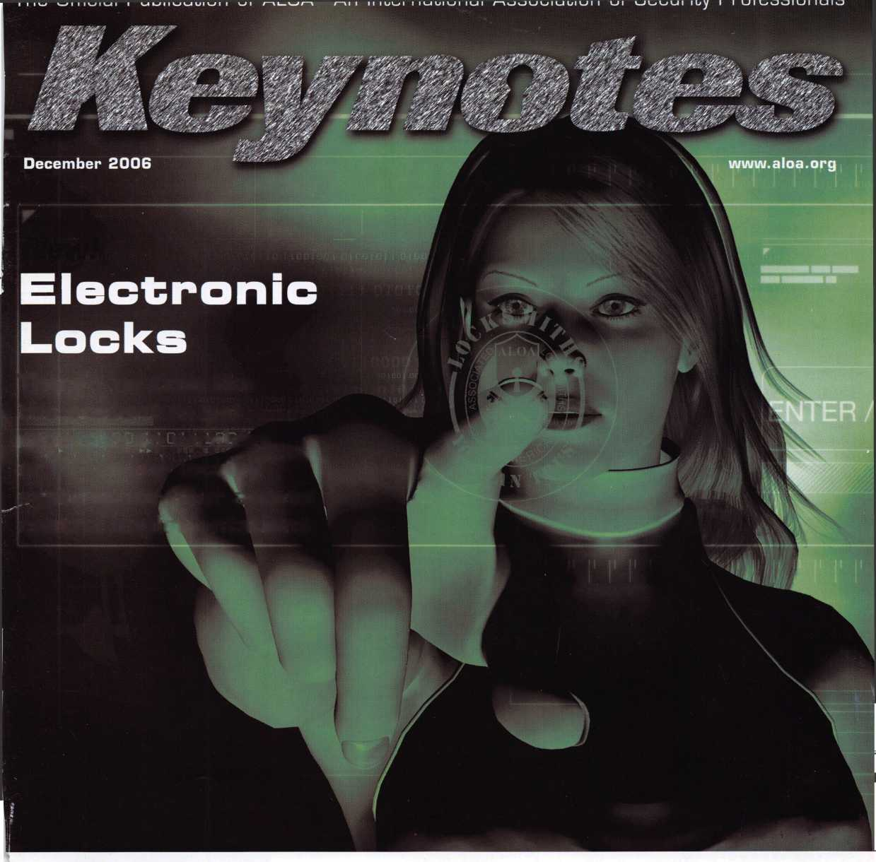

*LOcKSMlTh*

Subject to availability and qualificafons, Aflstj Company, Bridgewater, NJ.The ' oped Hand!

ete Insurance Comj^mpSwfTOistate Indemnity Company, Northbrook,,IL. Allstate County Mutual Insurance Company, Irving,IX. Allstate New Jersey Insurance MMPHwfSteredservice mark and "Our Stand" is a service mark of Allstate Insurance Company. ©2005 Allstate Insurance Company, Northbrook, IL.

/instate

You re in good hands.

**OUR STAND**

**IT’S QUITE POSSIBLY YOUR MOST**

**TRUSTED SIDEKICK**

**Keep it in Good Hands® with Allstate.**

As a small business owner, there are few things you quick certificates of insurance, ID cards, assistance

rely on more than your vehicle to keep you going. with the claims process, and more. All from one of

Your local Allstate agent can help protect it and the most widely recognized names in the business,

your small business with services you need including Are you in Good Hands®?

1-800-859-0247

**CALL NOW TO LOCATE YOUR NEARBY ALLSTATE AGENT.**

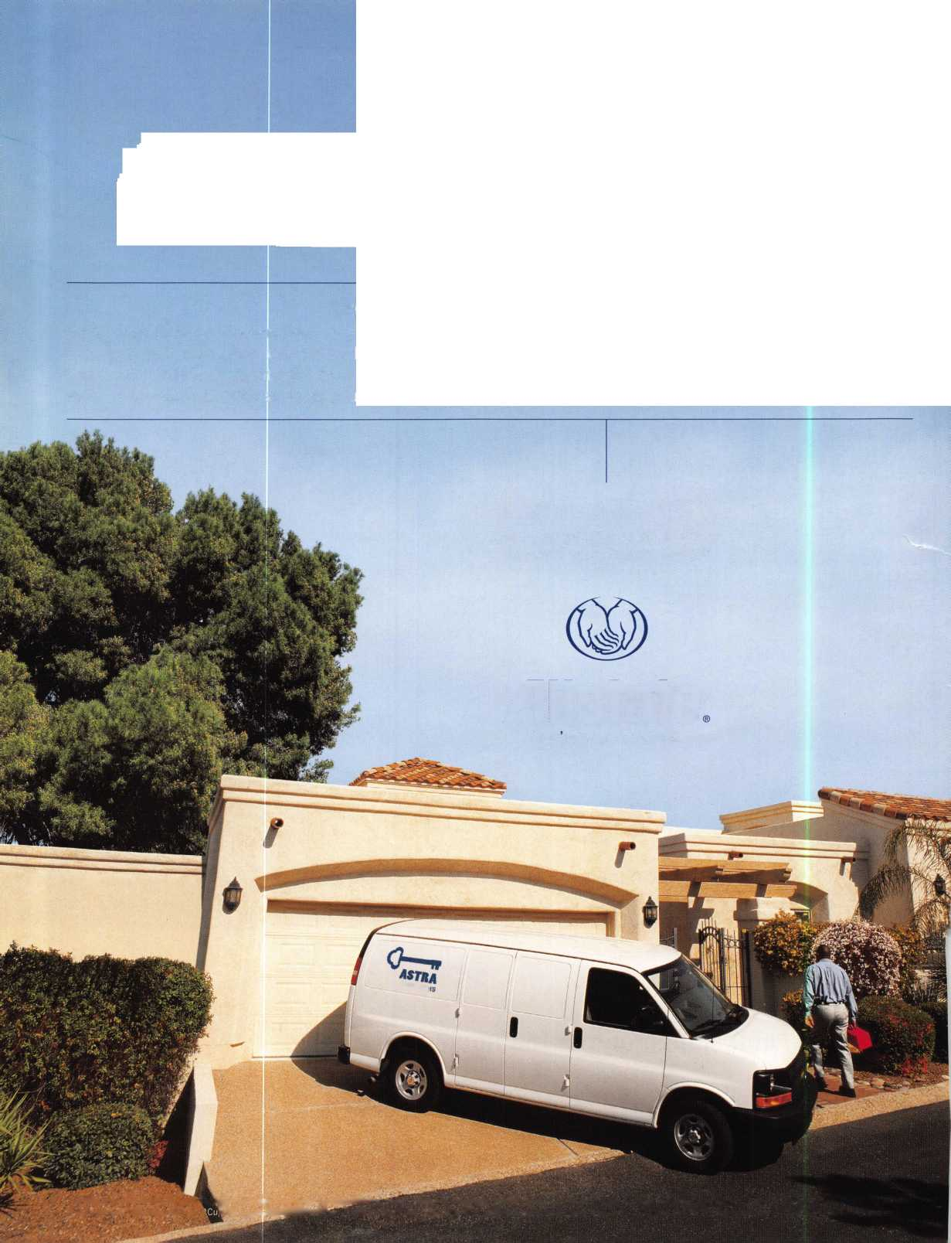

A Name You Know

As a business owner, you know the importance of a good name. Your name is your reputation. Your name stands for all that you offer in products and services. It’s a symbol of who you are. So, we thought you might like to know that Allstate, the name you know for insuring your personal vehicle and your home, also offers a business auto policy to help protect vehi­cles used in your locksmith business.

The following are coverages typically included in our business auto policy that might be important to you as a business owner:

Business Auto Liability coverage

* Higher limits up to $2,000,000 per occur­rence.
* Protects you if you are legally responsible for injuries and damages arising out of the ownership, maintenance, or use of business vehicles.
* Cost is based on several factors, including garage location, type and use of vehicle, and the violation and accident activity of your drivers.
* Additional Insured coverage may be required when you contract with govern­mental agencies or bid on local commercial jobs.
* Generally not available on a personal auto policy.
* Usually is no charge to add an insured to a Commercial Auto policy.

Hired Auto coverage

* Provides liability coverage for those vehicles you rent, hire or borrow for business use.
* The premium for hired auto liability coverage is based on the estimated annual rental cost.
* Tools and Special Equipment
* Provides protection to permanently attached equipment on your vehicle.
* You will need to let your agent know the value of the equipment to include in the cost of the vehicle.

You’re good at your business. Your insurance com­pany should be the same way.

Contact an Allstate agent to discuss your business auto insurance needs. To be referred to an agent, please call 800.859.0247 or email [abisO@allstate.com](mailto:abisO@allstate.com).

Subject to availability and qualifications. Insurance coverage is subject to policy terms.

Allstate Insurance Company

Allstate Indemnity Company Northbrook, IL

Allstate County Mutual Insurance Company Irving, TX

Allstate New Jersey Insurance Company Bridgewater, NJ

allstate.com

© 2005 Allstate Insurance Company, Northbrook, IL

Get What's  
Coming To You

AIOA continues to provide you with this and other great benefits and services!

310-515-5021

UL)C|JL2J uUULJiij 1

CiJCSXD

aoo

^ mg

iiiiiiiiiii

isp

*Jm*

illllll

*warn*

Need information in a hurryP Use ALOA’s Fax On Demand service.

m

Just call 310-575-5027 and receive:

1. ALOA Index of Documents (1 pg)
2. Reasons to Join ALOA (2 pg)
3. Locksmith Career Summary (3 pgs)
4. Locksmith School List (1 pg)
5. ACE Class Schedule (1 pg)
6. Certification Information (5 pgs)
7. PRP Category List (1 pg)
8. ALOA Membership Application (1 pg)
9. ALOA List of Benefits (1 pg)
10. ASF Scholarship Application (1 pg)
11. ASF Scholarship Information (1 pg)
12. ALOA Video Library Order Form (1 pg)
13. Safe & Vault Technicians Association Membership

Application/Subscription Form (2 pgs)

1. Recertification Information (4 pgs)
2. Legislation Action Network Newsletter (2 pgs)
3. Various State Law Issues (8 pgs)
4. Industry Position Paper (1 pg)
5. ALOA Convention Class Schedule (3 pgs)
6. ALOA Convention Class Descriptions (30 pgs)
7. ALOA Convention Registration Forms (4 pgs)
8. Board of Directors Nomination Form (2 pgs)
9. ALOA Company Membership Application (2 pgs)

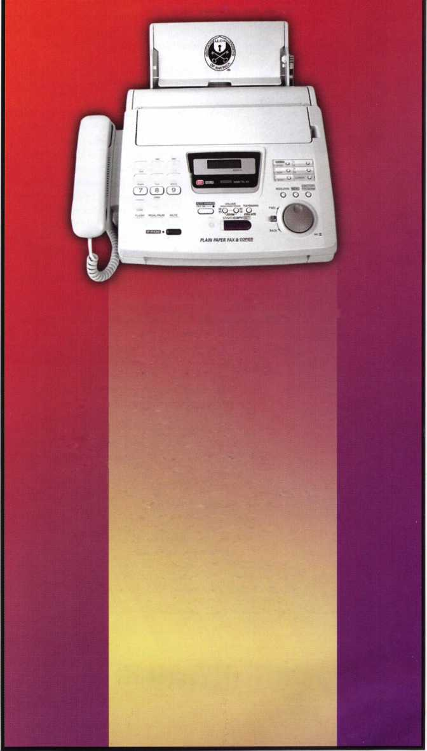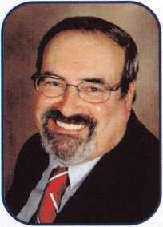

Dear Members,

As the year 2006 is quickly drawing to a close, there doesn't seem enough hours in a day to get all that needs to be  
done accomplished. It seems that I'm in one meeting or another and my suitcase hasn't been in the closet since Sep-  
tember. I'm not complaining; this simply means our association is on the move. The "status quo" is being left behind  
as more and more of our members seek an active voice and participation in our association.

The Greater Philadelphia Locksmiths' Association's convention was a  
salute to ALOA and our fiftieth anniversary. At their banquet, they  
honored us with a plaque which will be hung in our headquarters in  
Dallas. They then presented to each of the past presidents who were  
present including me, a plaque as a memento of our service to ALOA.

There were nine ALOA presidents attending the event. Past president  
David Lowell received the Gerald J. Connelly Pioneer Award and  
past president, Bill Young received the Lee Rognon Award. Also  
attending were ALOA presidential candidates Ken Kupferman, Joe  
Lee, and Hans Mejlshede and Northeast Directors Robert DeWeese  
and Tom Foxwell. Constant Maffey, RL was to be the honorary chair-  
man at the convention, but could not attend due to poor health. Get  
better, Connie! Our world is left with a big gap when you cannot be  
among us. Our booth was well attended, with Bill Gibson, David Low-  
ell, Bob Stafford, and our newest staff member, Ellen McEwen, Mem-  
bership Development Manager, meeting and greeting the many con-  
vention attendees.

As you may have guessed, I have to write the presidential message  
almost a month ahead of the time you read it. So, as I compose his  
message I am preparing to go to Korea to meet with our chapters in  
Asia. As ALOA becomes more and more an international organiza-  
tion, we must maintain our contacts around the world. In this way we  
can grow, learn and truly make ALOA a place to share our goals,  
knowledge and ideals.

December is a month full of holidays that involve lights, Christmas, Hanukah, and Kwanzaa, to name a few. May the lights of these celebrations bring forth a thankfulness of what we have today and to that end, I wish everyone a very happy holiday with a new year of bright new beginnings.

Take 'er easy!

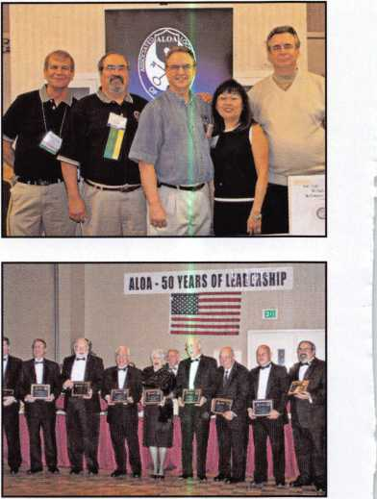

Sincerely,

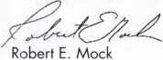

Keynotes • December 2006

**GKL**

i Prod new j

nnnm

SCHLAGE

GAL-ROYAL

DOR-O-MATIC

*"**'*Q)mOC

CHICAGO

**MONARCH**

**LCN**

Compc

NATIONAL

**VisalacK**

(Met

OLYMPUS,^

GbmXL0CK'iNC

TORT

**ASSA** CHmiX

NORTO

TIMBERLINE

**SARGENT**

DON-JO

**ylRROW**

VON DUPRIN

*roots*

*\*' BUUMI1*

*A ABLE*

©asp *T-COOi*

**AVENGER**

BOXERU.

**HEH Jet teohncs**

**LOGKCRHFT^**

**BIANCHI**

**iLABlMAfQjR**

**PI «OK**

*fpeterstm^UtCLfl*

***UxksmHh !m>h MM***

*HATASTBCK*

*r/nnSDD*

***AUTOMOTIVE***

Jg DEMAND **41 LOCKCRAFT^**

©ASP' ***DETERMINATOR***

*^Kutein MAJOR HATA*

*C/W—*

STRATTEC

*Wedfec&r\**

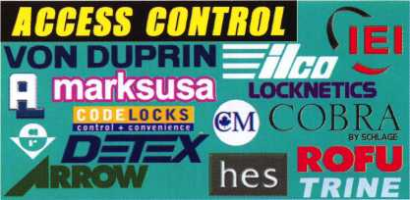

*Should you have questions about setting up*

*PHD10CKS*

Master Lock

an *access control system including:  
wiring diagrams, switches, & installation  
information, give Bill or Paul a call @*

**800-231 -4105**

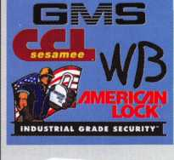

**KUL ©@o**

**Special Next Day Air Prices!**

*Place your order by 5 PM CST  
& get your order before noon the next day!*

**CALL US!**

*Sales Team with over  
65 Years Experience as Locksmiths!*

e

fiiin

■IpIII11

800-231-4105

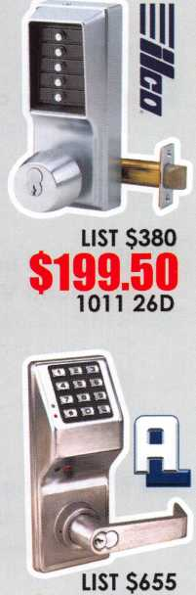

$299.50

DL2700 26D

i jiDDe I  
, sd n? [  
i arms I  
•orte  
! no |

lxnfV|

> vnne '

; COOOOCKS.COM |j

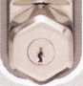

LIST $126

$ 82.50

CL210SS

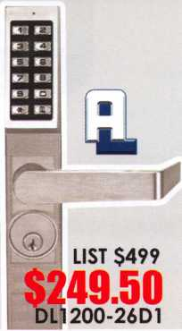

Lifetime Warranty

3

a)

$261.00

iQlK/ME*F

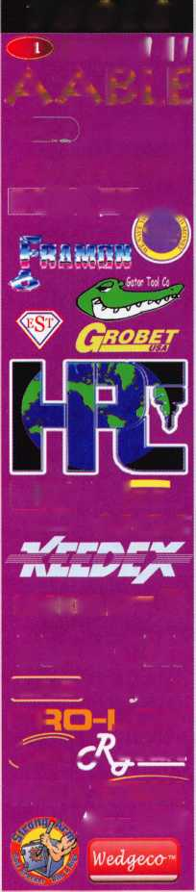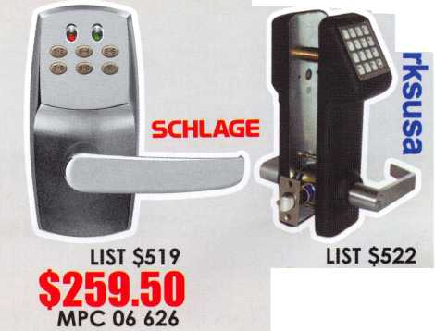

f

a

t

u

ELECTRONIC LOCKS 2006

New Schlage Electronic Locks

The lastest and greatest in electronic locks from Schlage.

Member Spotlight:

John Griswold, CML

Find out more about John and his Connecticut lockshop.

Product Knowledge

Knowledge is Power! Learn how to use product knowledge to your selling advantage.

by Claire Cohen, CML

Why Renew Membership in ALOA?

Find out the many NEW and great reasons to renew your membership in ALOA.

Becoming a CML

Read one mans journey to becoming a Certified Master Locksmith.

by Jeff Gater, CML, CPS

Diamond in the Rough - The ISM Diamond Vault

So did this safe need to be drilled or should good diagnostics and vibration open this safe without drilling?

by Greg Perry, CMLCPS

AD INDEX

**Allstate Inside Front Cover**

**Fax on Demand 1**

**HL Flake 3**

**ALOA 2007 7**

**Safetech 2007 19**

**Clearstar 21**

**Doorking 23**

Eliminating Office Chaos

Need some office structure in your life? Find out how a few basic steps can clear the clutter.

**Turn 10 32**

**Ultralift 33**

**A&B 40**

**Locksmithing UNL 40**

**NC Locksmithing Association Ad 40**

**HL Flake 41**

**ALOA Member Recruitment 43**

**Door Jam Armor Inside Back Cover**

**CCL Back Cover**

Departments

Presidential Viewpoint 2

Executive 5

App icants 6

Calendar 8

Core 9

Classified 34 Legislative 38

Associate Members 36

Visit our NEW website at [www.aloa.org](http://www.aloa.org)

executive



Volume 52, Issue 11

Additional contact information for the ALOA Board is available on the ALOA website—  
[www.aloa.org](http://www.aloa.org) or by contacting the ALOA office at 3500 Easy Street; Dallas, TX 75247;  
(800)532-2562; FAX (214)819-9736; e-mail [aloa@aloa.org](mailto:aloa@aloa.org).

Editor & Director of Creative Services

Betty Southerland [betty@aloa.org](mailto:betty@aloa.org)

Advertising Sales

Kim Hammond voice: 817-645-6778

Fax: 817-645-7599 e-mail: [adsales@aloa.org](mailto:adsales@aloa.org)

Executive Director

Charles W. Gibson, Jr., CAE [charlie@aloa.org](mailto:charlie@aloa.org)

Associate Executive Director

David Lowell, CML, CMST [david@aloa.org](mailto:david@aloa.org)

Convention & Meetings Manager

Jo Anne Mims [joanne@aloa.org](mailto:joanne@aloa.org)

Operations/Membership Manager

Mary May [mary@aloa.org](mailto:mary@aloa.org)

Director of IT Operations

Greg K. Jackson [greg@aloa.org](mailto:greg@aloa.org)

Comptroller

Kathy Romo [kathy@aloa.org](mailto:kathy@aloa.org)

Membership Development Manager

Ellen R. McEwen [ellen@aloa.org](mailto:ellen@aloa.org)

Membership Coordinator Shelly Jett

Convention & Meetings Assistant Karen Lyons  
PRP/Education Coordinator Shelley Melton

Mail Room Coordinator Kevin Wesley

Graphic Designer Margarita Garza

Accounting Coordinator Joyce Nixon

Executive Assistant Sue Langford

Assistant Education Manager Bob Stafford

Legislation Manager Tim McMullen

Contributors

Jerome Andrews, CML  
Paul Chandler, CRL  
Claire Cohen, CML  
Brian Costley, CML, CMST  
Eric Costley, CRL

Ray D'Adamo, CML Billy Edwards, CML Dan Graffeo, CRL,CMST Jim Hancock, CPL Jeff Nunberg, CML, CMST

Randy Simpson, CML, CPP Robert Stafford, CML Dave Thielen, CML Greg Perry, CML,CPS

Tom Seroogy

Charles Stephenson, CPS

Dennis Watanabe, CML, CMST

Mission Statement: The Associated Locksmiths of America, Inc. is dedicated to enhancing the professionalism, education and ethics among  
locksmiths and those in related sectors of the physical security industry. With approximately 10,000 members in the United States, Canada and the  
freeworld, ALOA is poised to help members obtain the knowledge, the strength, and the confidence to perform their role in the physical security field  
with pride and dignity. But it is only through active involvement and participation that ALOA can fully achieve its potential—and can help members to  
achieve theirs.

Policies: **Keynotes®** is the official publication of the Associated Locksmiths of America, Inc. (ALOA). **Keynotes**® acts as a moderator without approving,  
disapproving, or guaranteeing the validity or accuracy of any data, claim, or opinion appearing under a byline or obtained or quoted from an acknowl-  
edged source. The opinions expressed by the authors do not necessarily reflect the official views of ALOA. Also, appearance of advertisements and  
new products or service information does not constitute an endorsement of products or services featured by the Association. The Association does not  
accept responsibility for the inaccuracy of any data, claim, or opinion appearing in this publication, due to typographical errors on the part of the  
authors, Association staff or its agents.

Editor's Note: This publication is designed to provide accurate and authoritative information in regard to the subject matter covered. It is provided  
and disseminated with the understanding that the publisher is not engaged in rendering legal or other professional services. If legal advice and other  
expert assistance is required, the services of a competent professional should be sought.

Authors' Payment: Payment for eligible submissions to Keynotes will be based on the following criteria: topic, time spent and past contributions. Authors who  
regularly submit to **Keynotes**® are generally paid a higher rate. The latter is especially true of authors who write to fit specific editorial needs and submit said copy  
by **Keynotes**® deadlines. As a general guideline: Average payment for a 750 word, business or 'light' technical article would be $200. Payment for a 1500 word  
article involving significantly higher time and research efforts would be $400.

Payment will not be offered for articles submitted by ALOA employees or members of the ALOA Board of Directors (unless material is of a technical  
nature), nor for articles submitted by a company that promote that company's products or services. ALOA reserves the right not to pay for articles sub-  
mitted by an individual(s) that promote a particular company's products or services.

Disclaimer: The Associated Locksmiths of America, Inc., (ALOA), reserves the right to refuse any article for any reason. Additionally, ALOA reserves  
the right to edit, amend or modify any article submitted for publication in order to preserve technical accuracy, clarity, fairness or grammatical cor-  
rectness. ALOA will make the best efforts to notify the author of any changes. The extent of ALOA's liability for any article or information contained  
therein will be a notice of correction or retraction in the next possible issue.

**Keynotes**® (ISSN 0277 0792) is published monthly except for the combined June/July issue by The Associated Locksmiths of America, Inc.,  
3500 Easy St., Dallas, TX 75247-6416. Telephone: (214) 819-9733; FAX (214) 819-9736; e-mail [aloa@aloa.org](mailto:aloa@aloa.org). Subscription rates for  
members—$15.00 per year. Periodical class postage paid at Dallas, Texas. POSTMASTER: Send address changes to: Keynotes, 3500 Easy St., Dallas,  
TX 75247-6416. © Copyright 2003, All rights reserved. No part of the contents may be reproduced or reprinted in any form without prior  
written permission of the publisher.

President

Robert Mock  
(856) 863-0710  
[president@aloa.org](mailto:president@aloa.org)

Secretary

John Soderland, CML, CMST  
(414) 327-5625  
[secretary@aloa.org](mailto:secretary@aloa.org)

Directors, Northeast

Tom Foxwell  
(410) 206-5772  
[nedirecfor@aloa.org](mailto:nedirecfor@aloa.org)

Robert D. DeWeese, CML  
(410) 285-0101  
[nedirector@aloa.org](mailto:nedirector@aloa.org)

Directors, Southeast

Tom Gillingham, Jr., CML, CPS  
(615) 264-0747  
sed i rector@a loa.org

Ken Kupferman, CML  
(813) 232-7600  
[sedirector@aloa.org](mailto:sedirector@aloa.org)

Director, North Central

William Smith, RL  
(920) 893-5282

Guy Spinello, RL  
(815) 394-1000  
[ncdirector@aloa.org](mailto:ncdirector@aloa.org)

Director, South Central

CD Lipscomb, CML, CPS  
(903) 874-3522  
[scdirector@aloa.org](mailto:scdirector@aloa.org)

Directors, Southwest

Greg Parks  
(858) 271-1155  
[swdirector@aloa.org](mailto:swdirector@aloa.org)

Julie McCiuney, CRL  
(714) 636-5652  
[swdirector@aloa.org](mailto:swdirector@aloa.org)

Director, Northwest

Keith E. Whiting, CML, CFL  
(360) 601-5656  
[nwdirector@aloa.org](mailto:nwdirector@aloa.org)

Director, European

Hans Mejlshede, CML  
(453)539-3939  
eurd i rector@a loa. org

Director, Associate

Dan Floeck  
(800) 231-4105  
asdi rector@a loa. org

Trustees

[trustees@aloa.org](mailto:trustees@aloa.org)

Randy Simpson, CML

(281) 240-5959

JohnJ. Greenan, CML, CPS  
(773) 486.2030

William Young, CML, CPS  
(610) 647-5042

Past Presidents

2003-2005 William Young, CML, CPS  
2001-2003 Randy Simpson, CML  
1999-2001 John Greenan, CML, CPS  
1997-1999 Dallas C. Brooks  
1995-1997 David Lowell, CML, CMST  
1993-1995 Breck Camp, CML  
1991-1993 Henry Printz, CML  
1989-1991 Evelyn Wersonick, CML, CPS  
1987-1989 Leonard Passarello, CPL  
1985-1987 Joe Jackman, CML  
1983-1985 Stanley Haney, CPL  
1981-1983 Louis LaGreco, CPL  
1979-1981 John Kerr, RL  
1977-1979 Clifford Cox, CML  
1974-1977 Charles Hetherington  
1972-1974 Gene Laughridge  
1970-1972 William Dutcher, RL  
1968-1970 Constant Maffey, RL  
1966"! 968 Harold Edelstein, RL  
1964-1966 William Meacham  
1962-1964 Robert Rackliffe, CPL  
1960-1962 Edwin Toepfer, RL  
1956-1960 Ernest Johannesen

Keynotes • December 2006

CO

MA



Brighton

Kristopher Kaiser

CT

Woodbury

William F. Duggan

Sponsor: Gilbert N. Wade CRL

FL

Debary

Chuck Farrell

Sponsor: Larry L. Puckett Fort Walton Beach

John D. Davis

Sponsor: Robert E. Mock Hudson

Carmine J. DeStefano

Sponsor: Ken Kupferman CML, CPS

Lehigh Acres Robert F. Mahler

Maitland

Oren Beno

Miami

Amaury Riquene

Sarasota

Robert D. Burbeck

Tarpon Springs

David T. Follett

Sponsor: Ken Kupferman CML,CPS

applicants

for membership

Bourne

William L. Eloranta

Sponsor: Robert D. Michalski RL, CPS

NH

Hanover

Christian P. Knowlton Sr

Sponsor: Henry H. Ilsley CRL

NM

Las Vegas

Vance A. Lucero

Sponsor: Vance A. Mabry CML

Poughkeepsie

John Biedinger

Watertown

Thomas N. Martinson

OK

Catoosa

Tony Vara no

Sponsor: Clifford D. Lipscomb CML, CPS

PA

Folsom

James C. Schaefer

Sponsor: Charles W. McCausland Jr; CRL

Sponsor: Kevin J. Hudak CRL

TN

Franklin

Timothy Holler

Nashville

David Greer

TX

Hurst

Michael Scofield

San Angelo

Patrick Staha

VA

Richmond

Brent D. DeJarnette CPL

Sponsor: Calvin G. Harris CML

WA

Walla Walla

Mark Thomson

Sponsor: James L. Hancock CPL

Wl

Beloit

Orville Brooks

Madison

Anthony R. Church RL

New Zealand

Christchurch Canter

Roger Barriball

Sponsor: Mark Rollo

These applicants are scheduled for clearance as members of ALOA. The names are published for member review and comment within 30 days of this Keynotes issue date, respectively, to ensure  
applicants meet standards of ALOA's Code of Ethics. Protests, if any, should be addressed to the Membership Department and must be signed. Active Membership applicants (a) have worked in  
the industry two or more years. Allied Membership (AL) applicants are not locksmiths, but work in a security-related field. Apprentice Membership (AP) applicants have worked in the industry less than two years.



Keynotes • December 2006



Start Your Engines!

This year, with a great location and a schedule chock-full of exciting classes and events, we are pulling out all the stops to celebrate the ALOA Convention and Security Expo in Charlotte, North Carolina.

Having built an international reputation among locksmiths as a powerful resource to explore industry innovation and form industry alliances, ALOA 2007 is the ideal place to learn, network or to showcase your security-related business on the show floor.

This year we've thought of everything from an exciting location to a comfort­able hotel and a convention center that is equipped to handle your every need. The exhibit hall promises to be overflowing with the latest technology and new mer­chandise.

**july** 22-29, 2007

charlotte, north Carolina

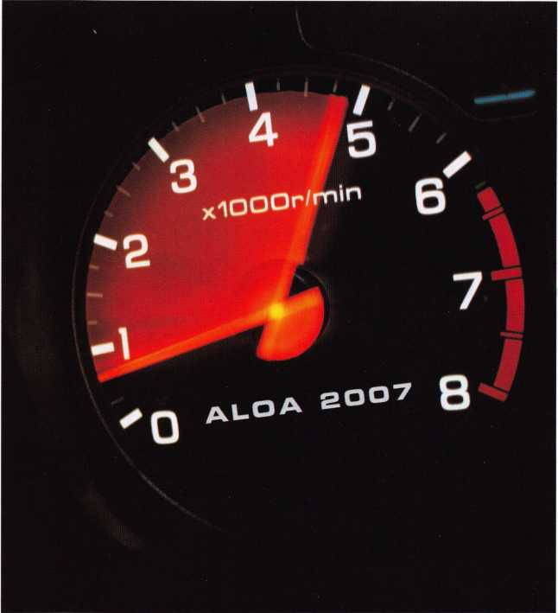

aloa convention and security expo

***51st ANNUAL***

Don't miss out

upcoming events

12/4 Dallas, Texas • ACE Classes ALOA Training Center Contact: [education@aloa.org](mailto:education@aloa.org) 800-532-2562x104

12/6 Hometown Buffett • Franklin, Ohio Ohio Valley Chapter Meeting, 7pm Contact: Chairman Terry McClain, CRL 513-464-8806

1/3 Hometown Buffet • Franklin, Ohio

Ohio Valley Chapter Annual Meeting Contact: Chairman Terry McClain, CRL 513-464-8806

3/7

2/3 Holiday Inn Select • Tulsa, Oklahoma

2007 Annual Distributor's Show, 9am-4prr Oklahoma Master Locksmith Association Contact: Harry Sher, CML 479-471-8890 • [hsher@starband.net](mailto:hsher@starband.net)

2/7

TBA • Franklin, Ohio Ohio Valley Chapter Meeting

2/14

TLA Convention • Houston, Texas. [www.texaslocksmiths.org](http://www.texaslocksmiths.org)

TBA • Franklin, Ohio Ohio Valley Chapter

4/4 Hometown Buffet • Franklin, Ohio

Ohio Valley Chapter Meeting Contact: Chairman Terry McClain, CRL 513-464-8806

UPCOMING ACE CLASSES

December 4, 2006 January 13, 2007

January 13, 2007

February 10, 2007

March 28 - 30, 2007

April 21, 2007 April 26 - 28, 2007

May 7- 12, 2007

July 22 - 29, 2007

Dallas, Texas • ACE Classes • ALOA Training Center Contact: [education@aloa.org](mailto:education@aloa.org) • 800-532-2562x104 Detroit, Michigan • Locksmiths Security Association Robert C. Noble, CML • Interchangeable Core Fundamentals

<http://home.earthlink.net/~lockwriter/idl> .html [noblelock25@sbcglobal.net](mailto:noblelock25@sbcglobal.net)

Casper, Wyoming • Wyoming Locksmiths Association Gene Ficek, CPL • Automotive Update with Trandsponders

Detroit, Michigan • Locksmiths Security Association Robert C. Noble, CML • Basic Electricity & Electronics w/Ll 3 PRP

<http://home.earthlink.net/~lockwriter/idl> .html

[noblelock25@sbcglobal.net](mailto:noblelock25@sbcglobal.net)

Vancouver, British Columbia • British Columbia

Association of Security Professionals

Bill Beazley • 14 ALOA Certified Classes

[lockpicker@helmz.com](mailto:lockpicker@helmz.com)

Kearney, Nebraska • Nebraska Chapter of ALOA Elmer Howard • Push Button Mechanical Lock Manipulation • [safeman@cox.net](mailto:safeman@cox.net) Denver, Colorado • Central & Southern Colorado Locksmths Association • Barry Meyers, CPL 9 ALOA Certified Classes Dallas, Texas • ALOA Training Center ALOA Education

Six-Day Basic Locksmithing Course [www.aloa.org](http://www.aloa.org) • [education@aloa.org](mailto:education@aloa.org) Charlotte, North Carolina • ALOA 51st Annual ALOA Education • 80 full day classes Convention & Security Expo • [education@aloa.org](mailto:education@aloa.org) 40 half day classes & evening seminars [www.aloa.org](http://www.aloa.org)

August 20 - 25, 2007

October 15-20, 2007

December 3 - 8, 2007

Dallas, Texas • ALOA Training Center ALOA Education

Six-Day Basic Locksmithing Course

[www.aloa.org](http://www.aloa.org) • [education@aloa.org](mailto:education@aloa.org)

Appleton, Wisconsin* Fox Valley Technical College

Ann Kading • Six-Day Basic Locksmithing Course

<http://www.fvtc.edu/tp2.asp?ID=Security%2FCrime+Pre>

vention&pix=005

Dallas, Texas • ALOA Training Center ALOA Education

Six-Day Basic Locksmithing Course [www.aloa.org](http://www.aloa.org) • [education@aloa.org](mailto:education@aloa.org)

UPCOMING PRP Sittings

12/9/2006

1/21/2007

2/10/07

2/11/07

2/17/07

3/10/07

3/31/07

4/22/2007

4/28/07

4/28/07

5/12/07

Saturday 3:00 pm • Dallas, TX • ALOA

ALOA Certification 800-532-2562 x203

Sunday 9:00 am-1:00 pm • Hebron, KY • CVG Airport

Ohio Valley Chapter of ALOA • 513-464-8806

Saturday 8:00am • Roseville, Ml

Locksmith Security Association

Sunday 8:00am • Welch, MN

Minnesota Chapter of ALOA

Saturday 8:00am • Houston, TX

Texas Locksmiths Assn.

Saturday 8:00am • Lexington, KY SAFETECH2007

Saturday 8:00am • Vancouver, BC

British Columbia Association of Security Professionals

TBA

Ohio Valley Chapter of ALOA • 513-464-8806

Saturday 8:00am • Roseville, Ml

Locksmith Security Association

Saturday 6:00pm • Denver, CO

Central & Southern Colorado Locksmiths Association

Saturday 3:00pm • Dallas, TX • ALOA Training Center

Contact the ALOA Education Department for a list of classes and training

offered in-house.

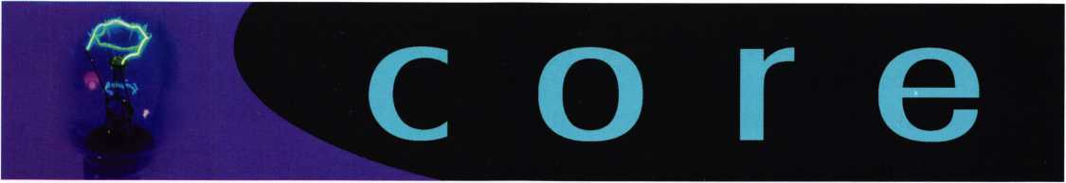

2006 Dodge ram on board key pro­gramming with 2 keys.

As some of you know I tried to program a extra key for my truck via onboard programming. We tried this during the PSC convention held in Portland OR in October, this was in a class setting and we were not able to do it.

The following is how I was finally able to program the key. The only thing I would like to modify is instead of the Security light flashing on my truck it was the check engine light (Engine Symbol) flashing.

1. Insert 1st valid key into ignition and turn ignition to the on position for at least 3 seconds (I did 5 seconds) Turn ignition off and remove first key.
2. Insert 2nd key and turn to the on position within 15 sec­onds. After 10 seconds the security light will begin to flash. Turn the ignition back to the OFF position and remove the second key.
3. Insert a unprogrammed key into the ignition and turn to the ON position. After 10 seconds the security light will stop flashing, and then it will come back on for 3 sec­onds then turn off.
4. At that point the key is programmed.

I want to point out this may not work for all vehicles. This is what I found on my 2006 Dodge ram. I have been told that the PT Cruiser, Dodge Caliber and the Ram are all having problems programming extra keys. Advanced Diagnostics currently does NOT have any software for the second gen­eration CAN system for these vehicles. The SDD does have the software.

I want to say thanks to Bill Blanchard from A-Max, and Steve Crabb from AA Express for working with me on get­ting this programmed. We have spent several hours trying to get info that was accurate.

William Botek CRL

ALOA has terminated its agreement with Service Magic

Service Magic should not, therefore, represent that they are endorsed nor affiliated in any way with ALOA. If anyone has contact with Service Magic and the company makes representation of affiliation with ALOA, please report that to Charles Gibson, [charlie@aloa.org](mailto:charlie@aloa.org). In addition, if any mem­ber has contracted with Service Magic and has a complaint about the company, that should be reported as well.

f

Clarification "Look Ma No Handle"  
Article from Keynotes October 2006

Trained GSA inspectors should contact their instructor if they  
have questions regarding opening containers or vault doors  
other than as prescribed in FED-STD-809. For opening by  
drilling outside the dial ring, students should contact the  
DoD Lock Program. The Lock Program will explain the pro-  
cedure and documentation required. If these requirements  
are met, the Lock Program may authorize the container /  
door to retain its GSA approval label.

New ALOA Slogan  
Unveiled

Soon you will be seeing the ALOA  
logo appear in publications with a  
new slogan. The new tagline was cre-  
ated to brand ALOA products and  
services so that consumers, members,  
and potential members know the vari-  
ous projects we do all come from one  
place, ALOA. If you use the ALOA  
logo on your marketing materials,  
please email [betty@aloa.org](mailto:betty@aloa.org) for an  
electronic copy.

ELF Convention 2007 Riga, Latvia 18th - 20th May

Come visit beautiful Riga where East meets West Exhibition - Social events -Education

Book now for cheap flights and superior hotel accommodation at reduced rates for Convention

For all information and Convention registration visit the website at [www.elf2007.com](http://www.elf2007.com) Or contact the Convention organizers on email: [ruta.reinika@prplus.lv](mailto:ruta.reinika@prplus.lv)



Wireless Access Systems

Offer Flexible, Innovative Integration Options

Depending on the Application - from Regular Doors to Elevators — Wireless Locking Systems Should Be a Consideration for Every Installation

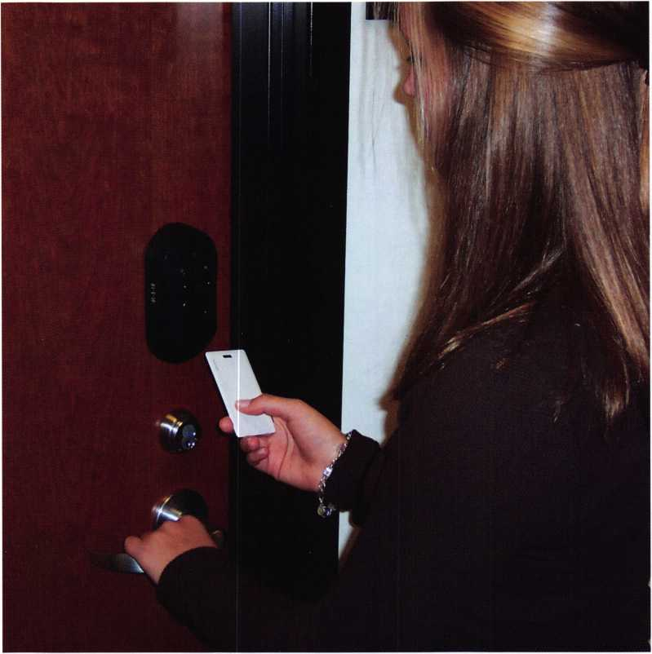

This wireless lock uses a proximity card to control ingress.

If you haven't considered wireless or RF on-line locking systems for your access control implementations, there's no time like the present to get receptive. You eliminate the cost of wiring and the components needed for wired sys­tems and installation time is typically reduced by up to 90 percent.

Occasionally an installation may call for a mix of locking solutions. There are now many locking systems available

At an installed cost start-  
ing around $655 US per  
door, programmable elec-  
tronic locks provide a  
solid choice for facilities  
with a limited number of  
users and access points.

A step above the tradi-  
tional generations-old  
strictly mechanical push-  
button lock, they are  
stand-alone, micro-  
processor-based, battery-  
powered locks that pro-  
vide increased customer  
value. Until it receives  
an authorized code, the  
clutching lever simply

gives way, discouraging vandals and others from breaking it  
to gain entry. These locks can quickly be programmed  
with individual user codes, right at the keypad.  
Administrators can easily add or delete users in less than a  
ten second process.

Computer-managed (CM) locking systems are ideal in situ­ations where older doors or facilities need to be retrofitted with higher-security locks. CM locking systems offer many

to meet almost any appli-  
cation. These range  
from standalone pro-  
grammable electronic  
locks to computer-man-  
aged (CM) models, hard-  
wired locks and a new  
entry, wireless locking  
systems.

Keynotes • December 2006

of the same benefits as a networked, hardwired system,  
without the higher cost and additional care associated with  
routing network cable when retrofitting an existing facility  
with electronic access control. These standalone, program-  
mable, battery-powered locks are networked through soft-  
ware to provide audit-trail capability and time-based sched-  
uling for restricting access. Whatever the credential used, a  
user-friendly software programs all, including the locks,  
access trim, and offline hard-wired controllers, which man-  
age strikes and magnets, from a laptop or PDA.

Beyond CM locking systems are the hardwired locks,

which let users use a  
CM-type lock to  
monitor door open-  
ings with their own  
existing, third-party  
access control panels  
and software. That  
means locksmiths  
don't have to go to  
the locks themselves  
to program them, or  
download audit trail  
information. This  
open architecture

platform seamlessly connects the specially designed door  
lock to a panel interface board (PIB) that connects to any  
present access control panel. There is no need for separate  
components or multiple manufacturers' products. Users  
access these locks with either magnetic stripe or proximity  
cards.

As a result, credential data and door status information  
required by the access control panel, such as door position  
or request-to-exit status, are passed via RS-485 communi-  
cation from the lock to the panel via the PIB provided with  
the locks. The access control panel maintains control of  
the lock status and status indication on these open archi-  
tecture locks as it does with present electric strike or elec-  
tromagnetic locking systems. All access events are centrally  
monitored and captured by the host system.

The Benefits of Wired Systems—

Without the Wire

Wireless or RF on-line locking systems are one of the fastest growing implementations in access control. These solutions seamlessly integrate into the access control panel, eliminating wire between the lock and the access control panel and providing a complete solution at each opening.

Wireless locks are not just used for doors. There are wire­less solutions for elevators, exit devices, gates and electric strikes. Notably, wireless systems easily integrate into any

existing access control system, which means users don't have to replace their existing keys or ID credentials. Such systems are an attractive alternative to off-line, standalone locking systems, because they offer a real-time solution that's compatible with all brands of access control panels.

Wireless systems typically operate up to 200 feet between the door and the panel interface module (PIM) for indoor applications. What’s especially important is you don’t need line of sight. Signals are able to penetrate cinder block walls, plasterboard walls, brick walls, and many other non- metallic materials for simplified system designs and imple­mentations.

For security integrators, wireless locking systems offer an opportunity to solve problems that might once have been impossible or impractical.

Benefits of wireless access control solutions include:

* Reduced installation cost by up to 35 percent or more.
* Reduced implementation time by up to 90 percent.
* Reduced disruption to facilities and workplaces.

**11**

Keynotes • December 2006

**ATTENTION**

AUTHORIZED  
PERSONS AND  
VEHICLES  
ONLY BEYOND  
THIS POINT

CAUTION

ACTIVE TAXIWAY AIRCRAFT HAVE RIGHT-OF-WAY

Using a proximity card, a truck is able to access a portable reader to open the gate at Renton Airport, south of Seattle.

Architectural integrity. Whether it's installed in new modern buildings or his­torical landmarks, wireless locking sys­tems preserve the integrity of the archi­tectural design. Another plus—potential asbestos issues are avoided entirely.

Go wireless for elevators too! While traveling cables are routinely included at the time on installation, they are often ill equipped to reliably transport creden­tial data from the cab to the elevator controller. Elevator shafts are harsh elec­trical environments and are often the source of data corrupting noise that becomes induced onto the card reader data lines. This causes inconsistent per­formance, which often gets worse over time as cable shielding decays due to continual movement.

Though wireless access systems can be used almost any­where locks are installed, there are certain applications that lend themselves perfectly to wireless solutions. Wherever time or budgets are constricted, airports, healthcare institu­tions, schools and universities, corporate facilities and other applications can all benefit. Wireless locking systems are extremely flexible. They work on wood and metal doors, both exterior and interior, as well as glass, monitored and scheduled doors, gates, elevators and in portable solutions.

Wireless systems offer many practical advantages.

Real-time event and status transmissions. Wireless locking systems provide the same online, real-time capabilities as wired systems. Access privileges can be added or changed at the central control terminal, all from a common database, which simplifies data entry and management. There is no need to tour the building to reprogram locks or download transaction logs and audit trails. All events are recorded in real time by the host access control system. In addition, all wireless transmissions are encoded using 128-bit private keys for heightened security versus traditional wired instal­lations!

Conversely, wireless solutions eliminate the need for the data lines in elevators up to 1000 feet. In fact, they thrive in this environment and provide consis­tent, reliable data transport that doesn’t wear out. With traveling cable installation costs ranging from $2,600 to $13,000 or more per cab, wireless alternatives can save thousands of dollars per elevator.

Eliminate trenching. For outdoor applications like vehicle and pedestrian gate access, wireless links can bridge up to 1000 feet line of site eliminating costly trenching. Wireless systems are ideal for garages, parking lots, airports, utility companies and military bases. They are especially cost effective for controlling gates around a facility. Even more impressive—optional directional or gain antennae are avail­able for still longer distances, such as the installation at a Middle East oil field where gates are controlled about 4000 feet away.

Easy temporary access points. Wireless, portable readers provide a quick and easy way to validate credentials for manned applications like checkpoint access, construction zone access, bus loading, perimeter expansion, mustering, and special event attendance. Simply take the wireless portable reader to the temporary location, and have card

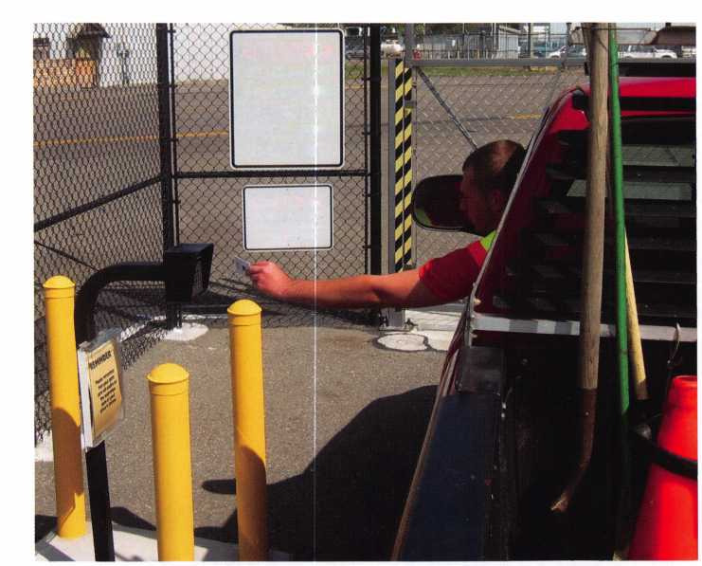

holders present their credentials. Operation is simple - a green light on the portable reader signifies a valid card; a red indicates an invalid card. The best part is all transac­tions are online and real-time from the same centralized database.

Wireless Systems: Robust and Reliable

With advanced transmitters and high sensitivity receivers providing optimal coverage throughout an area, today's wire­less access control is nothing short of robust. Moreover, Spread Spectrum technology, which sends the same data over many frequencies simultaneously, makes wireless redundant and thus extremely reliable. Wireless solutions also have a built-in red alert. They're supervised by a signal called a Heartbeat. If for some reason the Heartbeat signal is inter­rupted, a warning signal is generated.

Radio frequency coverage testing is essential to a successful wireless installation, however. Test kits are available that are purposely detuned to 50 percent power and are recom­mended to validate system designs and to optimize place­ment of panel interface modules. This ensures reliability prior to installation. In this manner, any weak spots are detected and corrections can be made before implementa­tion, not after.

Even in installations with a lot of concrete and steel, such as at the University of New Hampshire, there have not been any problems with the wireless access control system receiving a signal. And by taking the wireless route for the 40 suites in the university's new Mills Hall dormitory, the University saved $50,000.

In Summary

The business case for deploying the new wireless systems in a wide variety of networked openings is compelling. Such installations demonstrate that a wireless solution can have a substantially lower installed cost than its wired alternative. Moreover, wireless systems use less hardware and install five to ten times faster. Retrofitting electronic access control systems is now made easy and affordable with wireless solu­tions, especially in situations where it might have once seemed impossible.

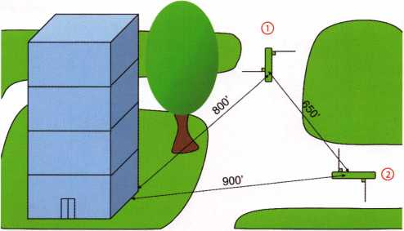

Wireless access control solutions are designed for outdoorapplica- tions as well. Unlike indoor applications which are rated at 200 feet, outdoor applications can run up to 1000 feet with their internal antennae. For longer spans, optional gain antennae may be used to bridge distances up to 4000 feet! Whatever the distance, however, direct line of sight is required between PIMs and wireless access points outdoors. In this example below, we'd like to add card access to two gates and control them from the main building. The wireless solution for gate 2 is pretty straightforward: Install a PIM near the edge of the main building and install a wireless reader interface at the gate. Gate 1 isn't so easy as the tall tree is obstructing the view to the main building. To overcome this, you'll need a repeater. The easiest option is to place the repeater at gate 2, which retransmits signals between the two-door PIM and the wireless reader interface at gate 1. This may seem complicated, but it is a lot simpler and much more cost effective than digging two trenches totaling 1700 feet.

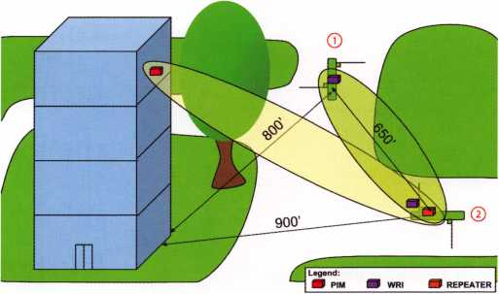

RF coverage can extend up to 4000 feet with optional gain anten­nae. In addition, repeaters can be used to circumvent obstructions or extend the range even farther.

**MEMBER\***

potlight

Welcome to our new monthly feature! Each month we will highlight a current ALOA mem­ber & their lockshop with a short bio and in-depth questions. To be considered or to recom­mend a fellow ALOA member please read the information provided at the end of this article.

ohn B. Griswold, CML has been an ALOA  
member since 1988 and has been active in

the locksmithing industry

for over 25 years.

Currently, John is a

proud owner of a  
small lockshop in

Wallingford,

Connecticut

called AA  
Lockserv.

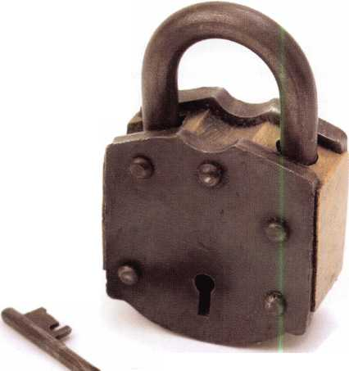

1. Tell us about your background in security and your experience in locksmithing.

Griswold: I've have been active in locksmithing for a little more than 25 years starting as a key cutter. Over the years I have worked for locksmiths, a hollow metal distributor and contract hardware company and a Locksmith Distributor. About 11 years ago I purchased a small locksmith shop and have been busy running it.

1. Can you remember your first big security job? What can you tell us about it?

Griswold: I had to rekey a hotel because someone had lost the master key. The maintenance man wanted to save money so he would bring the locks one floor at a time into me at 5:00am and they needed to be rein­stalled by check in time. It was about 200 doors, between 20 and 30 doors per floor.

1. What is your favorite place  
   in CT? Why?

Griswold: My home. It seems  
to be the place I spend the least  
amount of time at.

1. How did you get involved  
   in the business?

Griswold: A friend had a lock-  
smith shop and asked me to  
come help around the shop one  
day and I stayed. I didn't know  
any better.

1. Tell us about the changes  
   youVe seen in security tech-  
   nology recently.

Griswold: When I first got into

the industry we installed deadbolts all day long. Now we do a few a week. Most doors come pre-bored, and with so many DIY's that part of the business has slowed. Also, when I first started customers would wait until you could schedule them, now everyone wants you there now.

1. Do you find that other locksmiths in the CT area work together on referrals and workflow?

Griswold: I've been very fortunate to know most of the locksmiths in CT and we get along well. I have referred work to many, and they have done so also.

1. How many employees do you have?

Griswold: It is a small family business with three employees.

***“The locksmith  
industry is  
sitting on a cliff-  
We can either  
become the  
leaders or we can  
he left behind. ”***

1. What advice can you give  
   to an aspiring security pro-  
   fessional?

Griswold: A few things come  
to mind - 1) watch your cash  
flow and purchase only what  
you need. 2) educate yourself  
and keep up to date with any  
new products, tools, codes  
that affect the security of your  
customers. 3) Make friends  
with other locksmiths, distrib-  
utors and manufacturers, they  
can be invaluable when you  
have any problems. 4)never  
sacrifice your integrity or you  
reputation just to make a sale.

1. How do you stay informed about new products and security techniques?

Griswold: I read all the trade magazines and frequently check online sites for new information.

1. How do you sell security to the public?

Griswold: I try to stress that locksmithing and mechan­ical locks are the foundation to any security system. That if you spend thousands of dollars on an alarm sys­tem with a standard keyed knob on the door, you don't have good security. If I am selling our company, I will mention our experience, our reputation and the high quality of the products we sell.

Keynotes • December 2006

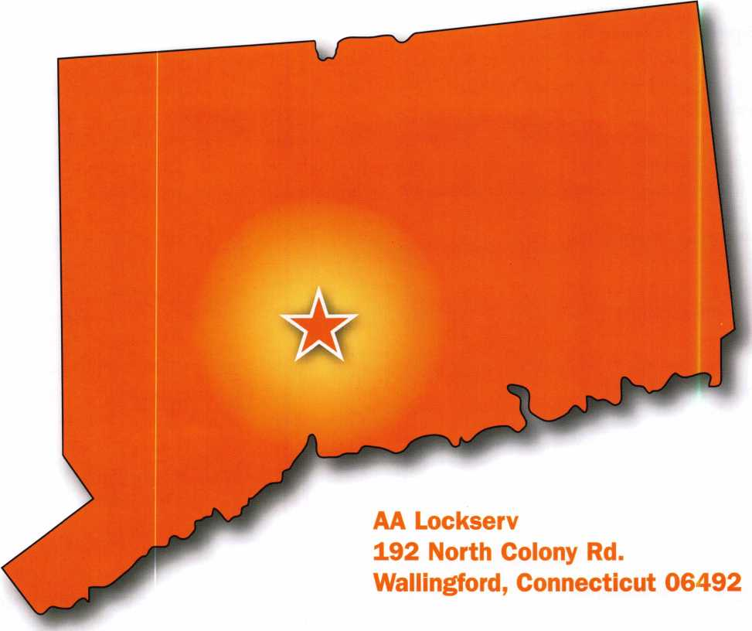

1. What do you see as the future of security? Where are we headed in today’s age of technology?

Griswold: Electronics and high security. There are so many industries trying to compete for the customer's money, we need to set ourselves apart. High security is a great equalizer for locksmiths. Home centers don't have the knowledge, personal or ability to com­pete with us on. That can change in the coming years with all the news about bump keys and other bypass stories. Electronics can be computer based or stand alone locksets. Electronic locks are easy to install and locksmiths will find this market to be very profitable.

1. Name one thing in your lockshop that says the most about you.

Griswold: I would say High security posters on the wall and displays of products that we use. My wife and daughter would say the clutter on my desk that gets deeper every day.

1. What do you like most about your job?

Griswold: I never liked repetition. So the challenge of locksmithing and the way each day is different has always appealed to me.

**6**

Keynotes * December 2006

1. How has life changed for you as a locksmith in the past few years?

Griswold: We have decided to concentrate on com­mercial customers and have stopped doing emergency work except for our regular customers. No more lock­outs or lost keys.

1. Name a few things that locksmith business own­ers should do to help their businesses prosper and grow.

Griswold: Everyone takes classes on impressioning and lock picking. It is time for locksmiths to also take business and marketing classes to get their business to grow. Learn the business side of the locksmith busi­ness.

1. Give us your biggest locksmithing horror story, toughest job, or the job that taught you the biggest lesson.

Griswold: Biggest lesson is probably purchasing some­thing that I really didn't need just to say I have the newest or best. Then realizing I didn't need it.

1. What is the best part of being a locksmith in America today?

Griswold: The locksmith industry is sitting on a cliff. We can either become the leaders or we can be left behind. We need to continue learning new things and being on the cutting edge of new technology. This is an exciting time for the forward looking locksmith.

1. Explain the rewards of being an active partici­pant in the profession as a whole, as opposed to someone just spinning their wheels trying to make ends meet at a shop.

Griswold: I had a lot of help in this industry through the years from other locksmiths and friends. So being able to answer questions, provide help, or advice to other locksmiths when they ask is a great feeling. It is simply payback for all those who helped me.

**\*You must be a current member of The Associated Locksmiths of America in order to be recommended for our Member Spotlight feature. If you would like to be recommended or would like to recommend some­one else please email our Keynotes Editor, Betty Southerland at [betty@aloa.org](mailto:betty@aloa.org)**

Keynotes • December 2006

BECOMING A



{ Certified Master Locksmith }

By: Jeff Gator, CPL, CPS

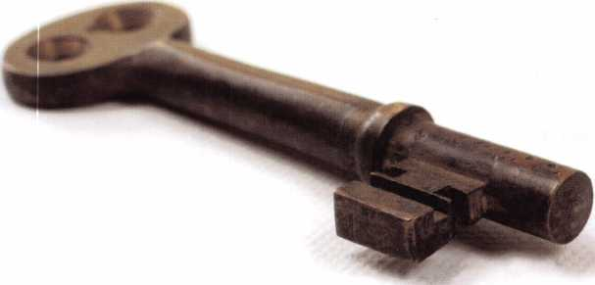

In 1977 I graduated High School. That same month,  
June, I also graduated from a correspondence school  
for locksmithing. The Foley Belsaw Course of  
Locksmithing, which I started in January of 1977...

Keynotes • December 2006



**MARCH 5th thru MARCH 10th, 2007**

**LEXINGTON**

**KENTUCKY**

**LEXINGTON’S**

**READY.**

**ARE YOU?**

This year  
we’re back in  
LEXINGTON  
for the 150th  
Anniversary  
of Sargent &  
Greenleaf.

Keeping up with the  
latest the industry has  
to offer has never been  
this important - or this  
FUN! When it comes to  
learning about the latest  
in safes and vaults, time  
is of the essence.  
SAFETECH 2007 fea-  
tures an all-new menu of  
classes, covering every  
safe topic on the globe.

*OUR SAFETECH 2007  
SPONSORS!!*

**SARGENT AND GREENLEAF**4

**SAFETECH**

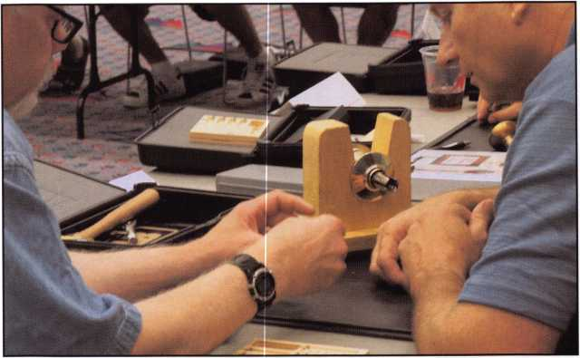

I was hired on my first job as a Locksmith Apprentice, July 2nd of that same year and summer vacation has never ended. Somehow, by fate, by luck, by the will of God, I found a trade and job I loved to go to. A trade that is wide as it is deep. A trade where the routine could be considered an art form, and the complex a challenge of shear delight. A trade where creativity, innovation, and the gift to understand how things work by fol­lowing a chain of cogs and linkages still exist. A trade where the highly technical and the basic mechanical often meet under the same cover plate. A trade which is infinite, boundless and team­ing with opportunities to those who will only look, learn and apply their craft with the highest degree of professionalism.

It is now 29 years later. I was taught early on the value of attend­ing classes and conventions by my most important mentor, John KeefeSr.,RL. When the Proficiency Registration Program (PRP) came out, I took the Mandatory and two electives in 1987. I passed my first time through and I thought I was somebody. A few years later I took the allowable 12 electives and passed one. The PRP did its job, showing me how little I knew about my chosen vocation.

Since then I have been taking classes with the intention of pass­ing an elective test on the PRP list. What I noticed was my new found knowledge made me notice code violations, door closers that needed adjusting, and the opportunity to sell master-key sys­tems under a patented keyway. The more my knowledge base widened the more money flowed into my pocket because I had the answers to customers needs.

I was taught early on the value of attending classes and conventions by my most important mentor.

John

KeefeSr.,RL.

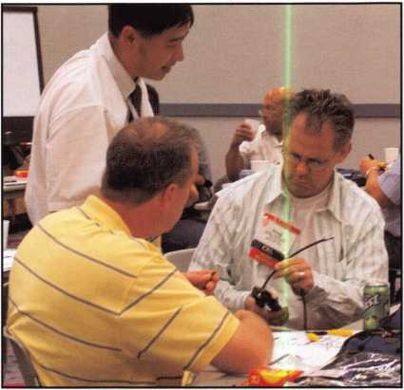

Keynotes • December 2006

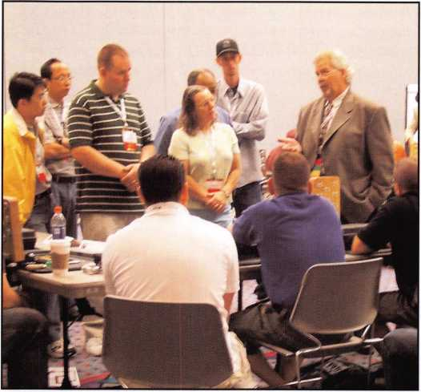

Some classes I took actually helped me decide not to pursue the class topic by investing more money in that phase of locksmithing, High Security Foreign Automotive comes to mind. Another class on making keys for motorcycles, taught by Ray D'Adamo, paid for itself several times over the first year after com­pleting the class.

At the time of this writing I am still a CPL. I am awaiting test results to see if I made CML, or still have more to learn to achieve this designation.

Either way I'm a winner.

Trying to achieve a Certified Master Locksmith Rating has made me something I did not figure on, a lot of money and the reputation of being a top pro­fessional in my community. ■

/

You need it When?

**How about now!? :-)**

**Clear Star dfl**

**Security , ^ Network V**

Another Special  
Value-added Benefit to your

ALOA Membership! Click here .

|  |  |  |
| --- | --- | --- |
|  | [www.clearstar.com](http://www.clearstar.com) / ALOA  C j |  |
| V |  | ) |

Keynotes • December 2006

Before starting this month’s article I need to make a couple of corrections. First, from the "Look Ma No Handle article Trained GSA inspectors are NOT allowed to go back to their instructor for approval to drill outside the dial ring or in other words other than prescribed by FED-STD- 809. They should contact their instructor to discuss the situation and perhaps get some guidance but ONLY the DOD lock program office can authorize any hole outside the dial ring. The Lock Program will explain the procedure and documentation required. If these requirements are met, the Lock Program may authorize the container / door to retain its GSA approval label.

The second correction concerns the terms I used in the article on the Green label Mosler file safe. I used the terms, confidential\ classified, secret and top secret. The correct terms for classified documents are confidential, secret and top secret. This particular customer was storing sensitive docu­ments not any level of classified documents. My sincere apologies for any confusion I might have caused and my thanks to Vaughan Armstrong, CMST, CML for his helpful input regarding GSA procedures and terminology for security containers.

So did this safe need to be drilled or should good diagnostics and vibration open this safe without drilling?

Diagnostics works to get safes open, or so I claimed last  
month. This month we’ll look at a recent opening  
where I felt certain of the problem and that it should

open without resorting to drilling. In the end  
drilling was the only way to get this safe open. I  
featured this exact safe in a June 2001 Keynotes  
article, about 10 years ago we had restored it

for sale to this customer. I’ve changed the  
combination a couple of times and serv-  
iced the locks, but they never wanted to

pay for a complete boltwork and  
time lock service. This is at the  
last commercial gold mine in  
California all the other com-

mercial gold mines have  
shut down due to high  
cost of gold mining in  
California. They  
poured their last bars of  
gold and locked them up in

the safe. The safe has serviced  
them well but now it won’t open.

So here are the details about the safe  
and it’s symptoms. First this safe is an

ISM Diamond Vault rated TRTL30x6 it  
has two combination locks, one S&G 8560  
manipulation proof and one S&G 6730.

Originally it likely came with a Mauer keylock  
instead of the 6730. Just to make sure we don’t

have a problem with the 8560 I checked to see if the  
bolt control handle moves further when the combina-  
tion is dialed and lock bolt is retracted. This lock  
appears to be and after opening the safe is operating

properly. Time to focus on the problem lock, here are  
the symptoms. Turning the dial indicates the faint feel  
of the contact points as the drive cam gate rotates under  
the lever nose. The combination was dialed and the

gate of the drive cam was moved under the lever  
nose, the dial was oscillated in an attempt to get

it to drop in case in the very unlikely event that  
one of the wheels drifted. The bolt control

handle was also rocked back and forth to

impart some vibrations into the lock,  
still not open. Dialing all wheels left

(or right) 4 turns and stopping at  
30 then slowly going back to the

right (or left) all three wheels

picked up within one num-  
ber of where they were left

indicating all the flys are  
operating properly.  
Probably not a stuck fly, so

what was next. Redialing the  
combination and leaving the

gate of the drive cam under the  
lever nose I tried using a deadblow

hammer to vibrate the face of the

door to get the lever nose to drop. Still  
not open but now I’ve lost the feel of con-

tact points. I think the lever is stuck, but  
why did I feel contact points at first, but not

now? Using an audio amp still did not reveal  
contact point sounds.

Puzzled I decided to dial the combination up and down by 10 numbers on each wheel and as a group. I also used the charts from Brian Costley’s publication



Keynotes • December 2006



Simple to use, install, and maintain. Basic digital entry as  
simple as a single stand alone digital keypad for economical  
applications - or programmable digital keypads with access  
for hundreds of users and multiple doors and/or gates.

Complete systems that can include electric locks and  
access control devices linked to weigand control boards -  
all manufactured by DKS.

* Durability - backed by more than  
  50 years of Made-in-the-USA

manufacturing and expertise f

* Outdoor use in all weather
* Easy to install magnetic  
  locks for both doors and  
  gates - a full line available  
  from 300 - 1200 lbs  
  holding force
* Vandal resistant - DKS

keypads feature:  
stainless steel  
faceplates, galvanized  
steel sub-plates, and  
rugged steel cabinets

We use DoorKing because they have a full line of products which provides us with one-stop shopping and they have a great customer service departmentV

*Scott Brose, Bejan Souferian* Co-Owners, Scotland Entry Systems, Inc.

Van Nuys, California

ACCESS CONTROL **SOLUTIONS**

for over fifty years

**surface mount**

Locking and Entry

**single and multi-door access control**

**flush mount**

**magnetic lock**

**1504 with intercom**

**Designing and Manufacturing** a **full line of product since** 1941

**Telephone Entry**

**Gate Operator**

**Parking Control**

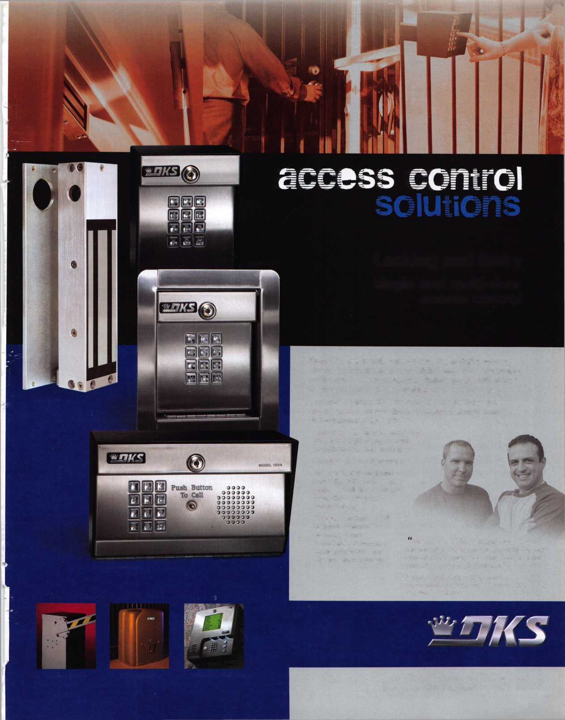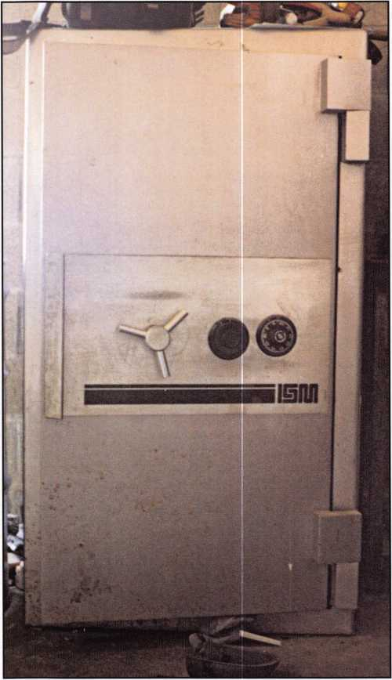

Photo 2, This is the inside of the side wall, although difficult to see the gold colored aluminum barrier layer, it can be seen in the hole.

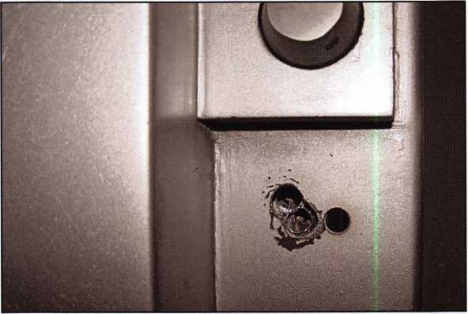

Photo 1, The outside of the door

Photo 3, This is the door side with the 3 holes.

“Dialing Diagnostics” to dial as if I had a stuck fly. I truly didn’t think these would unlock the safe but spending the 30 minutes to double-check seems like good practice. I would hate to drill the safe only to find out I missed something obvious. Still not open and more convinced that the lever is stuck I decided to try again the deadblow hammer and vibration of the lock bolt through the bolt control handle. Still no luck, time to drill, but where? I didn’t expect that it would not open so I didn’t make up a puller as suggested by some other authors, instead I decided for a more direct shot into the lock.

Drilling the sidewall on this level of safe is not easy.

This safe is TR (tool resistant) TL (torch resistant) 30 (minutes) x 6 (6 sided protection). The walls are con­

structed of 5 layers of different material. The outer and inner layers are made of steel. In between are a layer of concrete type material, a hardened steel layer, a copper layer and a layer of aluminum alloy. This material is designed to gum up and clog the flutes of the drill bit. Speaking with Jeff Volosing of Strong Arm Drills I found out he recommends spraying the flutes of the drill bits to prevent clogging. I tried a different tech­nique; drilling about a 1/4” deep at a time with a small­er bit then switching to a larger bit to enlarge the hole before going back to the smaller bit to drill some more. Eventually I penetrated the side of the door and had a look around. Unfortunately I drifted a little behind the lock. I tapped directly on the lock case to vibrate the lever still without luck.

Keynotes • December 2006

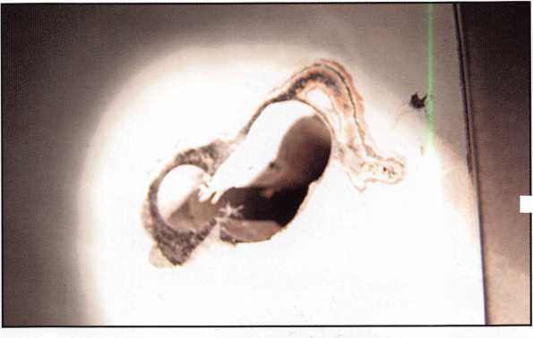

{

j

i

i

**Adesco FireKing/Gary Meilink**

OR SAFES THAT FIT EVERY NEED AND BUDGET, COUNT ON THE TRUSTED BRANDS OF FlREKlNG® SECURITY GROUP. ADESCO® OFFERS SAFES FOR GOVERNMENT, COMMERCIAL AND RESIDENTIAL CUSTOMERS. MEILINK® PROVIDES FIRE- AND B U RG LAR Y-R ATE D SAFES FOR BANKS, SCHOOLS AND RETAIL ESTABLISHMENTS. AND FlREKlNG FEATURES UL®-RATED FIRE/ IMPACT/BURGLARY RESISTANT SAFES BACKED BY OVER 50 YEARS OF SECURITY EXPERIENCE. PLUS, EACH BRAND COMES WITH EXCLUSIVE 24/7/365 TECHNICAL SUPPORT. SO FIND OUT MORE ABOUT FlREKlNG SECURITY GROUP. YOUR CUSTOMERS TRUST YOU TO RECOMMEND THE BEST. TRUST US TO PROVIDE IT.

at

If FireKing

W/Sm 1 SECURITY GROUP W

[www.fireking.com](http://www.fireking.com)

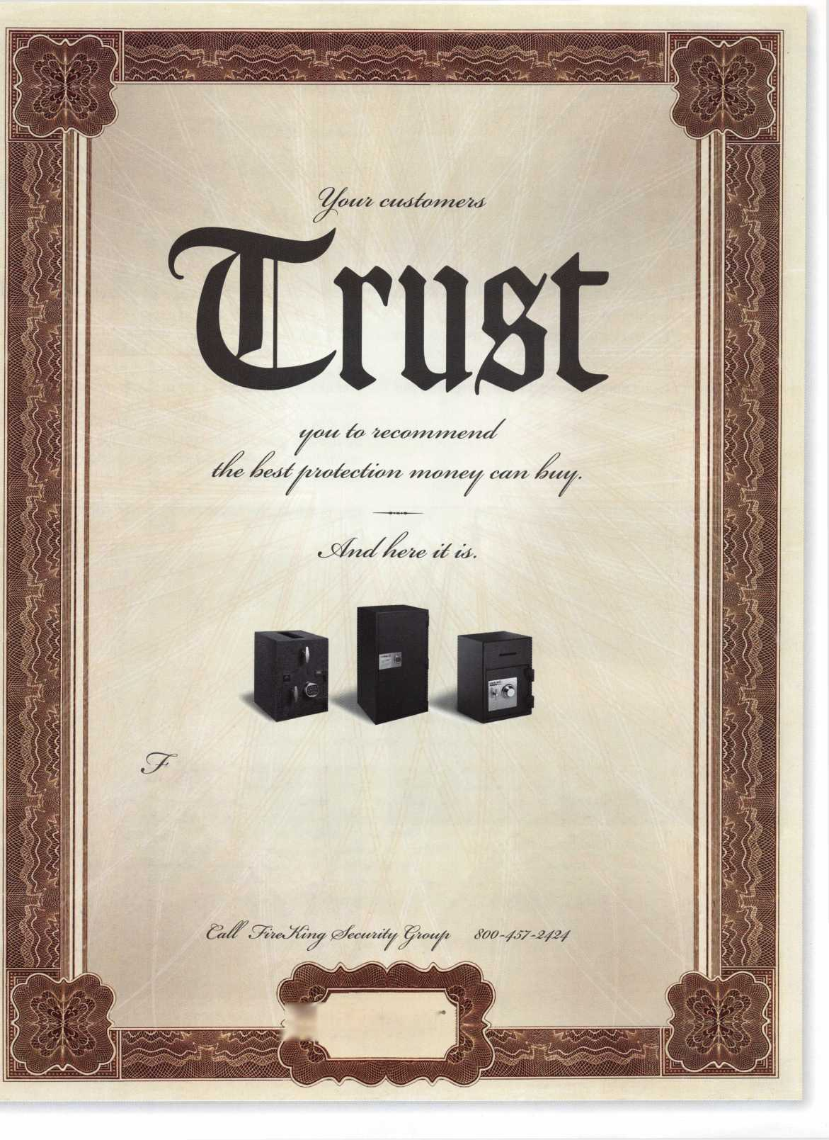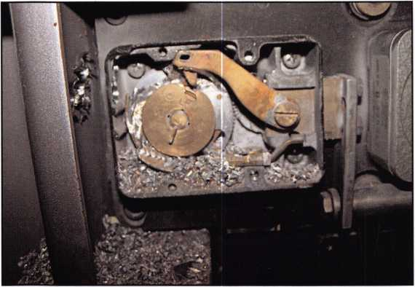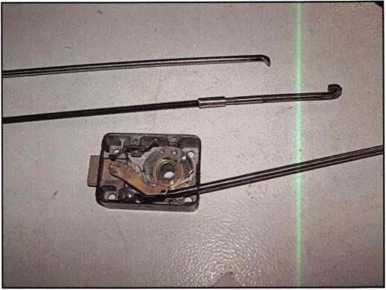

Photo 4, The not so pretty (but open) inside of the lock.

This photo shows the lever stuck against the lever stop. This picture was taken after the safe was opened, the door lock bolts extended and the combination lock bolt extended. It was at this point I found the hardened grease preventing the full extension of the lock bolt.

Photo 5 shows the tool in the lock made from air hard­ening drill rod with a screwdriver handle used to pry the lever into the drive cam gate. The bent end of the tool was sharpened parallel to the shaft of the tool. A sec­ond tool is sharpened in the opposite direction or 90 degrees to the tool used. The puller rod tool is between the lock and the second tool. Normally the puller would be used to grab the strap of the lock bolt extension either below or above the lock, depending on how the safe was produced.

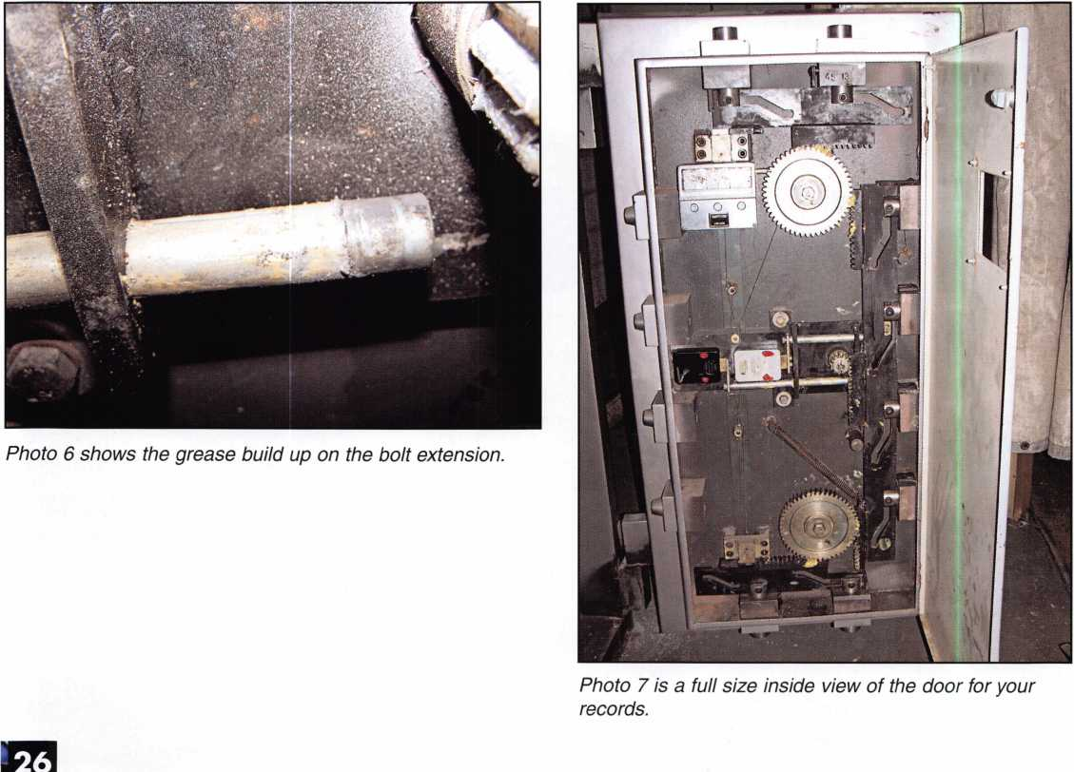

Keynotes • December 2006

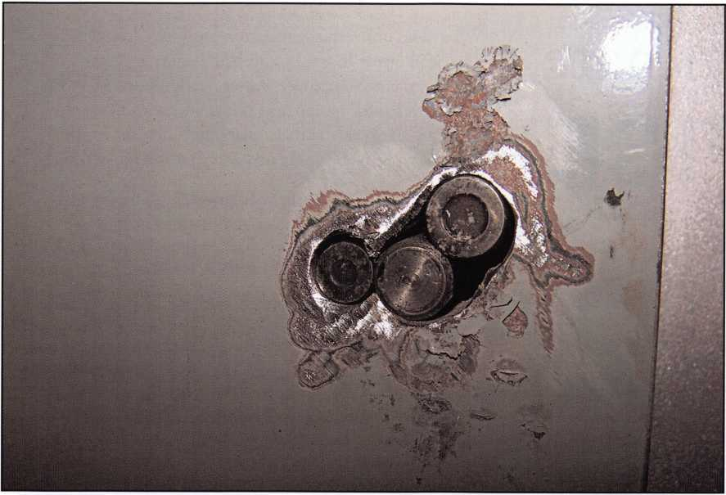

Photo 8, the three tapered needle bearings are ready to be welded.

Instead of drilling a new hole from the outside I angled the drill through the existing hole only drilling the inner portion of the safe wall to enter the lock case. Once inside the lock case I could see the stuck lever. Try as I might I still was not able to get the lever to drop using a stiff bent piece of welding rod. Again I drilled the hole up and to the front slightly to drill through the top of the wheel pack and remove the fence. Even with the fence gone the lever would still not drop. The next problem was they were quit­ting for the night and kicked me out. Not a big prob­lem it gave me time to get some larger bits from Jeff and also make a couple of prying tools out of drill rod and screwdriver handles. I also produced the puller in case I needed to drill and pull the bolt extension back. Going back two days later I drilled the outer skin to match my third hole to the inside and drilled the existing holes to 1/2”. This allowed me to watch with a scope as I used the homemade tool to pry the lever into the drive cam. Turning the dial retracted the lock bolt.

So what caused the lockout. Look at photo 5, the grease from 10 years ago finally built up enough on the lock bolt extension bar to prevent full extension. The drive cam would force the lever out of it against the lever stop and I believe a slight flex in the exten­sion from the lock bolt to the bar to wedge tighter against the lever stop. The repair was effected with several tapered pins from wheel bearings welded from both sides and then spot putty added to smooth the outside. Of course the boltworks were fully disassem­bled, the old grease removed and lubricated with fresh grease. The 6730 lock was replaced and the 8560 was serviced.

So did this safe need to be drilled or should good diagnostics and vibration open this safe without drilling? Photo 4 is not doctored; after the door was open we extended the bolts and watched the lever get stuck against the lever stop. It took a little force to get it to drop. I believe drilling was the only option. Perhaps I should have built the bolt extension puller and used that method, but the end result is the same, safe is open and the customer is happy. ■

Keynotes • December 2006

**2**

Eliminate

OFFICE

By: Laura Leist



What does office disorganization cost your company? The Wall Street Journal published a study indicating that the average employee wastes nearly six weeks a year looking for information and things in their office. Multiply six weeks by their salary and then the number of employees in the company, and that is a lot of money!

Can you relate to any of the following organizing mis­conceptions? If you can, you’re not alone.

If Ifile it, I’ll never find it again

The key to a great filing system is the ability to “retrieve” the information when you need it. The act of “filing” the paper away is simple - the critical step lies in how you categorize it so that you and others can access it.

If I hire an Office Manager / Office Assistant - theyll get me organized

Many managers and business owners become frustrated after hiring an office manager or assistant because this individual has done very little to help them get organ­ized. In order for this individual to be successful, there must be systems and processes that they can follow on a daily, weekly, monthly basis. Typically, this person is not the individual that will “create” the systems or processes but rather “maintain” them. In many cases, the individ­ual hired to work in this role may not have the back­ground to develop those processes or systems for you - yet they are excellent at using the systems. It is critical that the Manager or Business Owner play a key role in the development of these systems because most likely they will be the ones using them long after the individ­ual hired to help them has moved on.

Being organized stifles creativity

We’ve all heard of “right brained” vs. “left brained” indi­viduals. Those that are “right brained” tend to be more creative and thus disorganized. The fact of the matter is that those that are “right brained” tend to be more “visu­al” and therefore they like to see what they are working on - and thus much of what they work on is out in the open. There is no right or wrong way to be organized - it’s really about creating systems and processes that the individual can maintain to be efficient and productive. The work can be out in the open, as long as it is done so in an organized fashion so that when the information is needed - it can be retrieved.

Keynotes • December 2006

Being neat and tidy is the same as being organized

Its easy to take a clean sweep off your desk top into a box, bag or desk drawer. This puts a Band-Aid on the problem, but doesn’t find a solution. In most instances, people desire solutions. The clean sweep may be a temporary solution, but at some point you must face the underlying disorganization.

No matter what excuse you use for it, clutter in your office, whether on your work surface or on the floor, can be extremely distracting. If you’re used to work­ing in this kind of environment, you may not even be aware that the clutter is distracting you. It also causes unnecessary stress, because the items lying around often represent unfinished business. Having a system and a place to put things in your office will help mini­mize the distractions and eliminate extra stress. Here are a few tips to help you declutter your office:

1. Magazine Holders - use them to store directories, software manuals, packages of computer software labels, folders, user guides, packages of computer photo paper. When placing on a shelf, you want to see the back of the holder instead of the contents - it gives a clean look.
2. Computer Software - If you do not have an IT department that stores software and the user manuals for you, you’ll want to set up a system in your office so you can put your hands on when you need it. Empty the contents of the boxes and keep the soft­ware and manual. Be sure you also keep the Product Key if not on the CD case or CD itself. User manuals can also be store in a magazine holder, in hanging file in your filing cabinet or even in a decorative box that sits on a shelf. Software can be stored in a binder or a box designed for software.
3. To be Filed - Establish a location in your office for papers that require no additional action but just need to be filed. Don’t allow this location to accumulate items that need action.
4. Receipts - Create a place for receipts you must keep. Make a decision immediately if you need to keep it. Most likely, if it is a business expense, you’ll need to keep it. If you file an expense report - keep an envelope for the period where you can place the receipts until you file the report - so you don’t miss out on being reimbursed for expenses. If you have your own business, be sure to label the type of expense immediately - it will save you hours of time later at tax time!
5. Names, addresses, email addresses and phone numbers - Establish a location in your office where you’ll keep these pieces of information until you have time to record them in your contact management pro­gram or address book. Use a folder that you keep close by or a small container into which you toss the information. Better yet, record it immediately and discard that piece of paper.
6. Bookshelves - When placing books on book­shelves, try grouping them by category. Instead of standing them all upright, try laying groups of books flat and stacked on top of each other. Bookshelves don’t need to be full of books from one end to the other. In between the groups, you can display a photo or special treasure to break up the sections a bit.

Not sure where to begin? Just pick one small area to start - and complete that area. You’ll have a wonder­ful feeling of accomplishment and then you can move on to other areas of your office. It’s never too late to enjoy the numerous benefits of working in an organ­ized office.

About the Author:

Laura Leist, author of “Organizing & Customizing with Microsoft Outlook 2003” and “Eliminate Chaos,” is an organizational consultant who provides serv­ices to individuals in their homes, small businesses and corporations. She serves on the board of directors of the National Association of Professional Organizers and has been recognized as one of Washington States 40 Under 40 Entrepreneurs in 2001. For more information, please contact Laura at 425-670-2551 or at [laura@eliminatechaos.com](mailto:laura@eliminatechaos.com).

**29**

Keynotes • December 2006

’ S***i****\*.1* ***k\****



Are you missing the key to gaining your customer’s trust and the ability to influence their buying decisions? BY CLAIRE COHEN, CML

**WINNING**

the

**SALE**

with

PRODUCT KNOWLEDGE

A solid understanding of the merchandise you sell and the services your company provides can be the secret of sales success. Use the knowledge you have about what you sell to your advantage.

Buyers seek solutions from security professionals who understand what they really need. Prepare to be a winner! Know your products and/or service inside and out.

Gain competence and become an absolute expert about the products you sell and the serv­ices your company performs. Educate yourself by talking to hardware manufacturers and their distributors. Others in your organization may be able to help you gain more insight in a particu­lar product or group of products. Don’t over­

look networking by reaching out to your local association members who may have had experi­ence with a product. Will one of your distribu­tors hold a class to discuss potential applications of a product?

Have confidence in your merchandise and serv­ices. This comes from becoming an expert on your products and knowing that your product(s) and/ or service offer the right solution for your customers’ security needs.

Recognize that you must commit yourself to the selling profession as part of what you do. Also, honesty about what a product can and cannot do, integrity and a sense of fairness are crucial for long-term sales success.

Keynotes • December 2006



Successful salespeople can turn product objections into sales. Product knowledge and awareness of your company’s service levels and that of competitors is essential. You should also be able to communicate and present this information at customer level. To capitalize on every sales opportunity you must leave no room for customer misunderstanding. Successful sales people can present the information in different ways for different customers. Strive to give your cus­tomers a clear understanding of your product, service or company.

Communicate product knowledge to others in your company. Staying in business today is a matter of continuous learning, and yet many businesses don’t do enough to educate their associates. Developing prod­uct and service knowledge helps to improve sales results throughout the organization. Helping others in your group to understand products and services can help a company grow their business. Many important parts of product education can be done informally through occasional meeting updates from distributors or vendors who share can product knowledge and

their applications or with more experienced members of your staff. Guarantee that every member of your organization who speaks to patrons is the expert that your customers expect them to be.

Product, company, and competitor knowledge can help sell benefits to consumers. Teach salespeople how to translate product features into the benefits that cause customers to buy. Ensure that every salesperson receives thorough and professional training on your products and services.

Develop a training program for any member of your organization who sells to customers. This will result in a staff whose expertise will have customers saying “yes” when they need a security professional.

Why do customers bypass the mass merchandiser / big box stores to seek the advice of a security profes­sional? Expert knowledge of your products and serv­ices, the ability to demonstrate those products, and explain the benefits to your customers can help you to win the sale! 1

IN-STOCK...MORE SAFES

***FREE Freight Program***

***(30 States)***

MSEC FireKing fiaidaB HAYMAN MEIUNK ytCTOlZ

TURfl tO

**WHOLESALE SERVICE**

800-848-9790

Keynotes • December 2006

***OPERATOR SAFETY***

Injuries can be virtually eliminated. Ultra Lift does the lift-  
ing so that operator effort required to complete a move is  
minimized. Heavy loads are broken back with ease. The  
operator stays in control by using a combination of motor  
power, balance and leverage in every phase of a move.

***REDUCE LABOR COSTS***

Fewer people are required for any move with Ultra Lift.  
Manpower can be scheduled more productively. Labor  
savings often pay for the Ultra Lift in one month.

***ELIMINATE DAMAGE***

Loads are broken back, set down and moved under power  
with maximum leverage and operator control. Gentle  
handling eliminates bumps, bounces and damage to the  
load and premises.

***INCREASE PROFITS***

Increased operator safety, reduced labor cost and elimina-  
tion of damage to the load and premises all contribute to  
significant increases in profits.

FOR LITERATURE, VIDEO OR ON-SITE  
DEMONSTRATION, WRITE OR CALL:

ULTRA LIFT CORPORATION

475 STOCKTON AVENUE, UNIT E  
SAN JOSE, CA 95126  
800-346-3057  
408-287-9400  
FAX 408-297-1199  
E-mail: [info@uItralift.com](mailto:info@uItralift.com)  
[www.ultralift.com](http://www.ultralift.com)

ULTRA LIFT supplies the power - so you don't have  
to. One person can safely and easily handle loads  
that usually require 2 or 3 people, even up or down  
stairs. Two people can handle most safes to 1500  
pounds. If safety is your concern, ULTRA LIFT is the  
best move you'll ever make!

**U.S. PATENT 4.570.953**

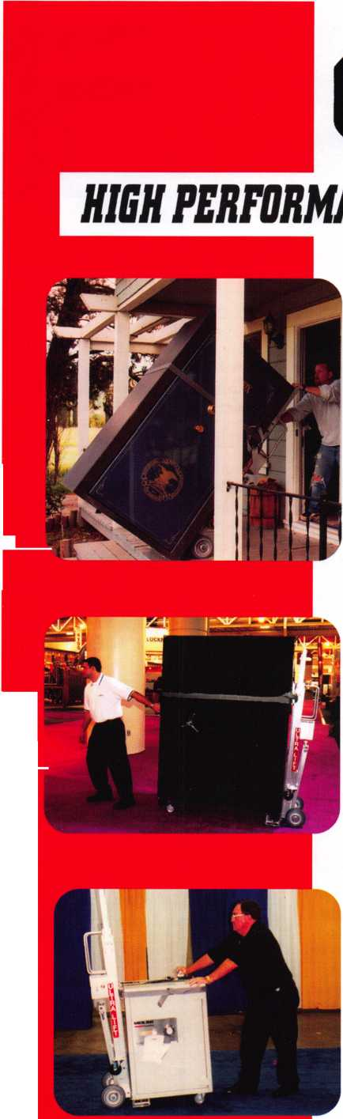

**Classifieds**



EMPLOYMENT

LOCKSMITH WANTED

Experience & hardware knowledge pre­ferred. Apprentice positions open for right individual. Excellent benefits include use of vehicle & tools, uniform, vacation and per­sonal time, health insurance, 401 (k). Background check required. Clean MVR required. Fax 303-291-01 13 or send resume & MVR to Colorado Doorways, 3333 E. 52nd Ave., Denver, CO 80216. [www.codoor.com](http://www.codoor.com), email: [hr@codoor.com](mailto:hr@codoor.com). EOE M/F/D/V

LOCKSMITH TECHNICIANS WANTED

In-house locksmith with experience road and shop work for commercial, safe and access control service. Salary plus benefits. See website or call for details. 713-755- 5906. Apply in person at 1310 Prairie,

2nd floor, Houston, Texas 77002. [www.co.harris.tx.us/hrrm/](http://www.co.harris.tx.us/hrrm/)

Employment.htm

LOCKSMITH WANTED

Locksmith wanted at Lee's Lock & Safe in Encinitas, California! Commerical, Residential, Electronic Access Control & Safes a plus. Fast paced and good bene­fits. Located in beautiful North Coastal San Diego County. In business since 1970.

Fax: 760-753-5851,

Ph: 760-753-0825.

LOCKSMITH WANTED

South King County Locksmith Company (locations in SeaTac and Federal Way) needs inside locksmiths as well as outside technicians. Top benefits package and top pay. Medical, 40IK, paid vacation and plenty of opportunity for advancement. We will supply everything you need (tools, truck, uniform)> Please email or fax resume

to: [paulbrandon@lockguys.com](mailto:paulbrandon@lockguys.com) or give me a call at 253-261-3870.

30819 Pacific Highway South Federal Way, WA 98003

LOCKSMITH WANTED

Busy shop in Woburn, Massachusetts seeks experienced Locksmith. We perform com­mercial, residential, safe, glass storefronts, card access, and automotive work includ­ing 2 AAA accounts. You don't have to know all these phases of locksmithing and we are also willing to train if interested. Sub-contractors welcome - Your van or ours. For more info please contact John at 781-933-9999 or send resume to: Locks & Keys, Inc. P.O. Box 222, Woburn, MA 01 801. Thank you for your consideration.

RELOCATE TO ALASKA

Action Security, Inc is a 44 year old securi­ty company that is interested in hiring you. It's services include electronic security, bank/credit union security; wholesale prod­ucts; hollow metal fabrication; contract hardware; retail security centers; and pro­fessional locksmith services. We have three retail locations and offer statewide services. We currently are in need of locksmiths, safe technicians, AHC's, CDC's, EHC's, electron­ic and bank technicians. Opportunity and professional growth is encouraged. Ideal candidate must be neat in appearance, people oriented, self motivated and hard working. Applicants must possess a good driving record, pass background and drug testing. We will train the right candidate. Action offers full benefits package; competi­tive wages; medical insurance; paid vaca­tion and sick days, continuous education and profit sharing. Please email resume to: i [nfo@actionsecurity.com](mailto:nfo@actionsecurity.com)

LOCKSMITH WANTED

A southern California locksmith company is looking for an honest, dependable, reliable and experienced locksmith. The company has been in business for 30 years and is looking for a locksmith to work both commericial and residential. Salary and commission, plus gen­eral insurance, paid vacation and 401K.

Fax resume to: 760-779-1 811.

WANTED

Qualified locksmith with at least five years experience in shop and on the road service. Applicant must be willing to relocate to Bermuda. Knowledge and experience in opening and servicing safes, combination changing, deposit box opening and servic­ing, installations, impressions, rekey and mas­ter key commercial and residential locks, Abloy, Medeco, Everest, llco Kaba high secu­rity locks. Paid vacation, holidays, major medical insurance, pension, tools and uni­form provided. Respond to:

Fax: 1-508-366-8864 Email: [barnes-lock@ibl.com](mailto:barnes-lock@ibl.com) Barnes Locksmith Service P.O. Box HM 636 Hamilton HM CX, Bermuda

EXPERIENCED LOCKSMITH

Established company in Central Virginia is looking for a locksmith experienced in com­mercial, residential and automotive. Great pay, insurance, retirement plan, paid vaca­tion and holidays. Needs to be motivated team player. Drug test, background check, good driving record required.

Send resume to:

Albermarle Lock & Safe Co.

51 3 A Stewart Street Charlotesville, VA 22902 Attention: Scott Megahan Fax. 434-971-8021 email: [alb.lock@yahoo.com](mailto:alb.lock@yahoo.com)

Keynotes • December 2006

EMPLOYMENT OPPORTUNITY

Locksmith - Entry Level/Experienced - A true career opportunity in Las Vegas for enthusias­tic and dependable people! A&B Security Group is seeking entry level or experienced locksmiths to join our dynamic and growing security services organization. On the job training and advancement opportunities into many areas such as alarms, CCTV, access control systems, safes and more. Join the A&B Security Group team and receive competitive salary and excellent benefits which include: Minimum first year salary $30,000, 401K, hospitalization package, paid holidays, com­pany vehicles, even a relocation allowance! A&B Security Group is currently accepting applications from interested and qualified candidates to fill the open Locksmith posi­tions. Come work for A&B Security Group in Las Vegas and you'll stay in Las Vegas! Apply on our website [www.227lock.com](http://www.227lock.com) or call 702-227-LOCK and ask for Phil today!

WANTED TO BUY/SELL

BUSINESS FOR SALE

Mom and Pop Locksmith and Screen Business for Sale in Golden Valley,

Arizona. Located between Kingman, AZ and Laughlin, AZ in fast growing Mohave County. Health and age are our reasons for selling. Our Dodge Ram Van and Business have more than $75,000.00 in equipment and inventory. All is included. Three bedroom, two bath 24x24 detached garage (which now houses the business) on 1.7 acre lot with all utilities and no assessments owed. Make an offer that is reasonable for this area. 928-565-2294 or email at [lmburks@citlink.net](mailto:lmburks@citlink.net)

BUSINESS FOR SALE

Sacramento, California Locksmith Business with two fully equipped vans, full inventory, tools, keys and code machines, etc. Established customer base since 1976, leased store in shopping center. Contact Walter Marcotte, owner, Jeff's Locksmiths. Lie# 706234 2377 Arden Way, Sacramento California 95825.

Fax 916-929-5945 Phone 530-674-3411 Randy's Cell Phone 916-600-1557

FOR SALE

Original Curtis key blanks.

Dan Barrow 601-624-8185.

LOCKSMITH BUSINESS FOR SALE

Located in Chicago south suburban area. Shop is well established, 35 years in same location, business has many commercial/industrial accounts. Equipment and inventory are included. Owner relocat­ing will help with transition. Please call 708-424-6953.

FOR SALE - ALL ITEMS LIKE NEW!

RETIRED - PRIMUS Demo kit with lock out cylinder - $195. Everest Demo kit - $195. Schlage Finish samples - $15. Solid Oak mount 44-112 - $50. Single mount com­posite material - $25. Sold individually or $425. Takes all!!!! Contact John L. Kish. Member# 12431 Telephone 1-888-7233.

Email: [kishjohn@softhome.net](mailto:kishjohn@softhome.net)

FOR SALE

Many new and gently used Omnilock OM and OP 2000 locks. For prices and more information, please email [Omnilocksforsale@aol.com](mailto:Omnilocksforsale@aol.com) or fax 860-346-6667

BUSINESS FOR SALE

Turnkey locksmith company incorporated. All inventory and equipment, new $10,000 computerized system, domain name, phone lines & vehicles. Prime loca­tion since 1979. High foot & return client business. Loyal employees, customer base includes national retail chains. Alarm and proprietary key systems assures repeat business. Grow in a vibrant area in Seattle, Washington, where new construc­tion projects abound. Call Verlayn McManus, RE/MAX Northwest at 1-866-733-5788 or send email to [vmc- manus@remax.net](mailto:vmc-manus@remax.net).

LOCKSMITH BUSINESS FOR SALE

Growing East Tennesse locksmith business established 1987. Supports three lock­smiths with two fully equipped vans serving residential & commercial accounts as well as walk-in customers. Business located in a 1152 sq.ft, concrete building on a 7500 sq.ft, corner lot fronting main hwy. Complete set up $225,000. Call 423-586- 3101 M-F 8-5.

EQUIPMENT FOR SALE

•1 llco 009 Tubular Key Machine, 120 Volt - $200

* 1 llco Exacta Punch Setup for Kwikset 5 & 6 Pin - $200
* 1 Framan #2 Code Machine 12 Volt -

$1200

* 1 Framan Express 12 Volt - $800

All prices plus shipping. 732-773-6447 or email: [ils245@comcast.net](mailto:ils245@comcast.net)

BUSINESS FOR SALE

Storefront and mobile services established for 24 years. Located in Southeast Kentucky. We serve several counties. We are now the only locksmith company in our town. With limited competition in area. We will include 2 fully equipped vans, many contracts, systems and inventory. Good location to raise a family, retire or escape the high pressure life. We have a good growth potential. Asking $65K or best offer. Selling due to personal reasons. Contact us at [sbvbky30@hotmail.com](mailto:sbvbky30@hotmail.com). Serious inquiries only.

MOBILE BUSINESS FOR SALE IN MIAMI, FLORIDA

15 year old, well established business.

90% commercial. Very good accounts. 2000 Ford Econoline Van .75 ton, HPC 1200, HPC 9160, all pinning kits, blanks, hand tools and stock included. $190,000. Also HPC 1200 blitz, 6 months old, 30 min use, $1,000.

Call Brad 305-233-4447

Classified Advertising Policy

Classified advertising space is provided free of charge to ALOA members and for a fee of $2.00 per word, $40.00 minimum for non members. Classified ads may be used to advertise used merchandise and overstocked items for sale, "wanted to buy" items, business opportunities, employment opportunities/positions wanted and the like. Members or non members wishing to advertise services or new merchandise for sale may purchase a "Commercial Classified Ad" for a fee of $4.00 per word with a minimum of $100.00. Each ad will run for two issues. For blind boxes there is a $10.00 charge for members and non members. All ads must be submitted in writing to the Advertising Sales Department via fax at 817-645-7599 or through an email to [adsales@aloa.org](mailto:adsales@aloa.org) by the fifteenth of the month two months prior to issue date. ALOA reserves the right to refuse any classified advertisement that it deems inappropriate according to the stated purpose of the classified advertising section.



Distributor

**1st In Hardware, Inc.**

Phone: Phone: 410-646-9900 Fax: 410-646-0045 www. 1 stinhardware.com

**ADEL Fingerprint Technology, LLC**

Phone: 909-595-1222 Fax: 909-595-1667

**Accredited Lock Supply Co.**

Phone: 800-652-2835 Fax: 201-865-2435 [www.acclock.com](http://www.acclock.com)

**American Auto Lock.Com**

Phone: 717-392-6333 Fax: 717-581-8353 [www.americanautolock.com](http://www.americanautolock.com)

**Andrews Wholesale Lock Supply**

Phone: 717-272-7422 Fax: 717-274-8659 [www.andrewslock.com](http://www.andrewslock.com)

**Boyle & Chase Inc.**

Phone: 800-325-2530 Fax: 800-205-3500 [www.boyleandchase.com](http://www.boyleandchase.com)

**Clark Security Products**

Phone: 858-974-6740 Fax: 858-974-6720 [www.clarksecurity.com](http://www.clarksecurity.com)

**Cook's Building Specialties**

Phone: 505-883-5701 Fax: 505-883-5704

**Dire's Lock & Key Company**

Phone: 303-294-0176 Fax: 303-294-0198

**Direct Security Supply, Inc.**

Phone: 800-252-5757 Fax: 800-452-8600

**Discount Key Machines.Com/Busch**

Phone: 800-332-8724 Fax: 407-363-4666

**Doyle Security Products**

Phone: 800-333-6953 Fax: 612-521-0166 [www.doylesecurity.com](http://www.doylesecurity.com)

**Dugmore and Duncan, Inc.**

Phone: 888-384-6673 Fax: 888-329-3846

**E. L. Reinhardt Co., Inc.**

Phone: 800-328-1311 Fax: 651-481-0166 [www.elreinhardt.com](http://www.elreinhardt.com)

**Ewert Wholesale Hardware**

Phone: 800-451-0200 Fax: 708-597-0881

**Foley-Belsaw Company**

Phone: 800-821-3452 Fax: 816-483-5010 [www.foley-belsaw.com](http://www.foley-belsaw.com)

**Fried Brothers Inc.**

Phone: 800-523-2924 Fax: 215-592-1255 [www.fbisecurity.com](http://www.fbisecurity.com)

**H.L. Flake Co.**

Phone: 800-231-4105 Fax: 713-926-3399 [www.hlflake.com](http://www.hlflake.com)

**Hans Johnsen Company**

Phone: 214-879-1550 Fax: 214-879-1530 [www.hjc.com](http://www.hjc.com)

**Hardware Agencies, Ltd.**

Phone: 416-462-1921 Fax: 416-462-1922 [www.hardwareagencies.com](http://www.hardwareagencies.com)

**IDN Incorporated**

Phone: 817-421-5470 Fax: 817-421-5468 [www.idn-inc.com](http://www.idn-inc.com)

**Instant Hardware Delivery, Inc**

Phone: 800-355-1107 Fax: 800-663-8518

**Intermountain Lock & Supply**

Phone: 800-453-5386 Fax: 801-485-7205 [www.intermountainlock.com](http://www.intermountainlock.com)

**International Electronics, Inc**

Phone: 800-343-9502 Fax: 617-821-4443

**Jo Van Distributors**

Phone: 416-288-6306 Fax: 416-752-8371 [www.jovanlock.com](http://www.jovanlock.com)

**L V Sales Inc**

Phone: 323-661-4746 Fax: 323-661-1314 [www.lvsales.com](http://www.lvsales.com)

**Lockmasters, Inc.**

Phone: 859-885-6041 Fax: 859-885-7093 [www.lockmasters.com](http://www.lockmasters.com)

**Locks Company**

Phone: 800-288-0801 Fax: 305-949-3619

**Locksmith Ledger International**

Phone: 847-454-2700 Fax: 847-454-2759 [www.lledger.com](http://www.lledger.com)

**McDonald Dash Locksmith Supply**

Phone: 800-238-7541 Fax: 901-366-0005 [www.mcdonalddash.com](http://www.mcdonalddash.com)

**Monaco Lock Co.**

Phone: 800-526-6094 Fax: 800-845-5625 [www.monacolock.com](http://www.monacolock.com)

**NLS Lock Supply Dba Nevada Lock S**

Phone: 702-737-0500 Fax: 702-737-7134

**Omaha Wholesale Hardware**

Phone: 800-238-4566 Fax: 402-444-1664 [www.omahawh.com](http://www.omahawh.com)

**Phoenix Safe International LLC**

Phone: 765-483-0954 Fax: 765-483-0962 [www.phoenixsafeusa.com](http://www.phoenixsafeusa.com)

**Positive Identity Solutions**

Phone: 704-663-1175 Fax: 704-660-1301 [www.pids-usa.com](http://www.pids-usa.com)

**Security Distributors Inc**

Phone: 800-333-6953 Fax: 612-524-0166

**Security House**

Phone: 905-669-5300 Fax: 905-660-6313 [www.securityhouselock.com](http://www.securityhouselock.com)

**Southern Lock and Supply Co.**

Phone: 727-541-5536 Fax: 727-544-8278 [www.southernlock.com](http://www.southernlock.com)

**Stone & Berg Wholesale**

Phone: 800-225-7405 Fax: 800-535-5625

**Streetwise Security Products**

Phone: 252-830-5577 Fax: 252-830-5542

**The Locksmith Store Inc.**

Phone: 847-364-5111 Fax: 847-364-5125 [www.locksmithstore.com](http://www.locksmithstore.com)

**Timemaster Inc.**

Phone: 859-259-1878 Fax: 859-255-0298 [www.time-master.com](http://www.time-master.com)

**Top Notch Distributors, Inc.**

Phone: 800-233-4210 Fax: 800-854-4146 [www.topnotch.bz](http://www.topnotch.bz)

**Turn 10 Wholesale**

Phone: 800-848-9790 Fax: 800-391-4553

**U.S. Lock Corp.**

Phone: 800-925-5000 Fax: 800-338-5625 [www.uslock.com](http://www.uslock.com)

**Wilson Safe Company**

Phone: 215-492-7100 Fax: 215-492-7104 [www.wilsonsafe.com](http://www.wilsonsafe.com)

Manufacturer

**A & B Safe Corporation**

Phone: 800-253-1267 Fax: 856-863-1208 [www.a-bsafecorp.com](http://www.a-bsafecorp.com)

**ABUS Lock Company**

Phone: 800-352-2287 Fax: 602-516-9934 [www.abus.com](http://www.abus.com)

**Access Security Products Ltd.**

Phone: 905-337-7874 Fax: 905-337-7873 [www.access-safe.com](http://www.access-safe.com)

**Adams Rite Mfg Company**

Phone: 800-872-3267 Fax: 800-232-7329 [www.adamsrite.com](http://www.adamsrite.com)

**Adesco Safe Mfg. Company**

Phone: 800-694-9340 Fax: 562-408-6427 [www.adesco.com](http://www.adesco.com)

**Adrian Steel Company**

Phone: 800-677-2726 Fax: 517-265-5834 [www.adriansteel.com](http://www.adriansteel.com)

**Advanced Diagnostics USA Inc**

Phone: 650-876-2020 Fax: 650-876-2022 [www.autokeys.com](http://www.autokeys.com)

**Alarm Controls Corporation**

Phone: 631-586-4220 Fax: 631-586-6500 [www.alarmcontrols.com](http://www.alarmcontrols.com)

**All Five Tool Company, Inc.**

Phone: 860-583-1691 Fax: 860-583-4516 [www.all5tool.com](http://www.all5tool.com)

**American Security Products**

Phone: 909-685-9680x2013 Fax: 909-685-9685 [www.amsecusa.com](http://www.amsecusa.com)

**BWD Lockcraft**

Phone: 973-728-3707 Fax: 973-728-3731 [www.bwdautomotive.com](http://www.bwdautomotive.com)

**Bianchi USA, Inc.**

Phone: 800-891-2118 Fax: 216-803-0202 [www.bianchi](http://www.bianchi) 1770usa.com

**Buddy Products**

Phone: 312-733-6400 Fax: 312-733-8356 [www.buddyproducts.com](http://www.buddyproducts.com)

**CCL Security Products**

Phone: 800-733-8588 Fax: 847-537-1800 [www.cclsecurity.com](http://www.cclsecurity.com)

**CompX Security Products**

Phone: 864-297-6655 Fax: 864-297-9987 [www.compxnet.com](http://www.compxnet.com)

**D&D Technologies (USA), Inc.**

Phone: 714-677-1300x292 Fax: 714-677-1299 [www.ddtechglobal.com](http://www.ddtechglobal.com)

Keynotes • December 2006

associate

members

**DETEX Corp.**

Phone: 800-729-3839 Fax: 830-620-6711 [www.detex.com](http://www.detex.com)

**Don-Jo Manufacturing, Inc.**

Phone: 978-422-3377 Fax: 978-422-3467 [www.don-jo.com](http://www.don-jo.com)

**Door Controls International**

Phone: 800-742-3634 Fax: 800-742-0410 [www.doorcontrols.com](http://www.doorcontrols.com)

**Door Jamb Armor**

Phone: 201-490-5381 Fax: 201-490-5389 [www.djarmor.com](http://www.djarmor.com)

**Doorking Inc.**

Phone: 800-826-7493 Fax: 310-641-1586 [www.doorking.com](http://www.doorking.com)

**Dorma Architectual Hardware**

Phone: 717-336-3881 Fax: 717-336-2106 [www.dorma-usa.com](http://www.dorma-usa.com)

**E-Lock USA**

Phone: 434-589-5913 Fax: 434-589-3738 [www.e-lock-usa.com](http://www.e-lock-usa.com)

**FireKing Security Products**

Phone: 800-457-2424 Fax: 800-896-6606 [www.fkisecuritygroup.com](http://www.fkisecuritygroup.com)

**Framon Manufacturing Company Inc.**

Phone: 989-354-5623 Fax: 989-354-4238 [www.framon.com](http://www.framon.com)

**G-U Hardware Inc.**

Phone: 757-877-9020 Fax: 757-877-9720 [www.g-u.com](http://www.g-u.com)

**HPC, Inc.**

Phone: 847-671-6280 Fax: 847-671-6343 [www.hpcworld.com](http://www.hpcworld.com)

**HY-KO Products Co.**

Phone: 330-467-7446 Fax: 330-467-7442

**Hammerhead Industries, Inc.**

Phone: 805-658-9922 Fax: 805-658-8833 [www.gearkeeper.com](http://www.gearkeeper.com)

**Ingersoll Rand Security Technologies**

Phone: 317-805-5713 Fax: 317-805-5779 [www.schlagelock.com](http://www.schlagelock.com)

**Jackson Corporation**

Phone: 323-269-81 1 1 Fax: 800-888-6855 [www.jacksonexit.com](http://www.jacksonexit.com)

**Jet Hardware Mfg., Co.**

Phone: 718-257-9600 Fax: 718-257-0973 www. j etkey s .com

**KABA ILCO Corp.**

Phone: 252-446-3321 Fax: 252-446-4702 [www.kaba-ilco.com](http://www.kaba-ilco.com)

**KEY-BAK/West Coast Chain Mfg.**

Phone: 909-923-7800 Fax: 909-923-0024 [www.keybak.com](http://www.keybak.com)

**Kenstan Lock Company**

Phone: 516-576-9090x315

Fax:516-576-0100

[www.kenstan.com](http://www.kenstan.com)

**Keri Systems Inc.**

Phone: 408-451-2520 Fax: 408-441-0309 [www.kerisys.com](http://www.kerisys.com)

**Knaack Manufacturing Co.**

Phone: 800-456-7865 Fax: 815-459-9097 [www.weatherguard.com](http://www.weatherguard.com)

**Kustom Key Inc.**

Phone: 800-537-5397 Fax: 800-235-4728 [www.kustomkey.com](http://www.kustomkey.com)

**LAB Security**

Phone: 800-243-8242 Fax: 860-583-7838 [www.labpins.com](http://www.labpins.com)

**La Gard Inc.**

Phone: 310-325-5670 Fax: 310-325-5615 [www.lagard.com](http://www.lagard.com)

**Lock America, Inc. dba L.A.I. Group**

Phone: 714-373-2993 Fax: 714-373-2998 [www.laigroup.com](http://www.laigroup.com)

**LockPicks.Com/Brockhage Tools**

Phone: 408-437-0505 Fax: 408-516-9642

**Lucky Line Products, Inc.**

Phone: 858-549-6699 Fax: 858-549-0949 [www.luckyline.com](http://www.luckyline.com)

**M.A.G. Manufacturing**

Phone: 714-891-5100 Fax: 714-892-6845 [www.magmanufacturing.com](http://www.magmanufacturing.com)

**MUL-T-LOCK USA, Inc.**

Phone: 800-562-351 1 Fax: 973-778-4007 [www.mul-t-lockusa.com](http://www.mul-t-lockusa.com)

**Major Mfg, Inc.**

Phone: 714-772-5202 Fax: 714-772-2302 [www.majormfg.com](http://www.majormfg.com)

**Maxcess Card Systems Ltd**

Phone: 949-492-5964 Fax: 949-492-0415 [www.maxcess-card.com](http://www.maxcess-card.com)

**Medeco Security Locks**

Phone: 540-380-5000 Fax: 540-380-5010 [www.medeco.com](http://www.medeco.com)

**Mil-Comm Products Co Inc**

Phone: 201-935-8561 Fax: 201-935-6059

**Promet Safe Inc.**

Phone: 860-436-6246 Fax: 860-436-6876 [www.promet-safe.com](http://www.promet-safe.com)

**Protex Safe Co., LLC**

Phone: 818-610-8030 Fax: 818-610-8004 [www.protexsafe.com](http://www.protexsafe.com)

**ROFU International Corp.**

Phone: 253-922-1 828 Fax: 253-922-7272 [www.rofu.com](http://www.rofu.com)

**Rutherford Controls Int'l Co.**

Phone: 519-621-7651

Fax:519-621-7939

[www.rutherfordcontrols.com](http://www.rutherfordcontrols.com)

**STRATTEC Security Corp.**

Phone: 414-247-3333 Fax: 414-247-3564 [www.aftermarket.strattec.com](http://www.aftermarket.strattec.com)

**Sargent & Greenleaf, Inc.**

Phone: 859-885-9411 Fax: 859-885-3063 [www.sargentandgreenleaf.com](http://www.sargentandgreenleaf.com)

**Sargent Manufacturing Co.**

Phone: 800-727-5477 Fax: 888-863-5054 [www.sargentlock.com](http://www.sargentlock.com)

**Schwab Corp.**

Phone: 765-447-9470 Fax: 765-447-8278 [www.schwabcorp.com](http://www.schwabcorp.com)

**Securifort Inc**

Phone: 819-359-2226 Fax: 819-359-2218 [www.securifort.com](http://www.securifort.com)

**Securitron Magnalock Corp.**

Phone: 775-355-5625 Fax: 775-355-5636 [www.securitron.com](http://www.securitron.com)

**Security Door Controls**

Phone: 805-494-0622 Fax: 805-494-8861 [www.sdcsecurity.com](http://www.sdcsecurity.com)

**Security Solutions**

Phone: 405-376-1600 Fax: 405-376-6870 [www.securitysolutions-usa.com](http://www.securitysolutions-usa.com)

**Select Engineered Systems**

Phone: 305-823-5410 Fax: 305-823-5215 [www.selectses.com](http://www.selectses.com)

**Townsteel, Inc.**

Phone: 626-858-5080 Fax: 626-858-3393 [www.townsteel.com](http://www.townsteel.com)

**Trine Access Technology**

Phone: 718-829-2332 Fax: 71 8-829-6405 [www.trineonline.com](http://www.trineonline.com)

**Videx Inc.**

Phone: 541-758-0521 Fax: 541-752-5285 [www.videx.com](http://www.videx.com)

**WMW Innovation Company**

Phone: 888-474-2341 www. su re-str i ke. com

Service

Organization

**Allstate Insurance Company**

Phone: 847-551-2181 Fax: 847-551-2732 [www.allstate.com](http://www.allstate.com)

**Cardservice Mobile Solutions**

Phone: 561-210-8488 Fax: 561-953-6268 [www.cardservicems.com](http://www.cardservicems.com)

**Cross Country Automotive Services**

Phone: 800-541-2262 Fax: 781-393-0256 [www.argosi.com](http://www.argosi.com)

**HRH Insurance**

Phone: 817-462-3630 Fax: 817-462-3680 [www.hrh.com](http://www.hrh.com)

**Massglass & Door Service**

Phone: 888-742-8837 Fax: 805-497-2255 [www.massglass.com](http://www.massglass.com)

**SalesGenie.Com**

Phone: 402-593-4500 [www.salesgenie.com](http://www.salesgenie.com)

**The Mechanic Group, Inc.**

Phone: 845-735-0700 Fax: 845-735-8383 [www.mechanicgroup.com](http://www.mechanicgroup.com)

**Webster Safe & Lock Co., Inc.**

Phone: 901-332-2911 Fax: 901-332-2878 [www.webstersinc.com](http://www.webstersinc.com)

Keynotes • December 2006

**3**



**IN PURSUIT OF ASSOCIATION HEALTH PLANS FOR LOCKSMITHS**

In 2003, the Associated Locksmiths of America, Inc. (ALOA) joined the Association Healthcare Coalition (TAHC), an alliance of over 35 trade and professional associations that seeks to pro­mote association-sponsored health plans as unique and viable mechanisms for providing affordable health care benefits to their member­ship (small and medium- sized employers). We did so because we wanted to offer our member­ship, which consists of mostly single owners or small employers, a chance to have health insur­ance. In America today, approximately 60% of all uninsured Americans are workers employed by a small business or the dependents of such workers.

20 years ago some associations, like the American Council of Engineering Companies, were able to offer nation-wide health insurance to their membership because state regulations were few and fairly consistent. With the proliferation of new rules and tighter controls over the last 10 years, now only a small handful of large associa­tions are able to offer such benefits (and TACH predicts those left will disband their programs over the next year). These impediments are what keep ALOA from offering its members health insurance.

In contrast, large corporate and union health plans are exempt from state insurance regulations and mandates. ALOA and TAHC are seeking the same opportunities provided to their counterparts

in large corporations and labor unions - afford­able health care through economies of scale, greater bargaining power with large insurance companies, regulatory uniformity, and the free­dom to design health plan options that meet work­ing families' needs.

Associations are uniquely structured to be part of the employer-based healthcare delivery system. Because they are already structured to represent their members in other areas, they possess the infrastructure, administrative mechanisms, and experience needed to unify employers and employees into effective consumers of health serv­ices. By serving this need for small employers, associations add value to the health care system as a whole, as well as to their members individu­ally. The bill would give insurance companies an opportunity to bid their health plans to AOLA so that we may offer the most comprehensive plan to our membership.

Now that the elections are over, ALOA is working with TAHC on the passage of Small Business Health Fairness Act of 2003. A similar bill already passed the House, and there are still a few more days in the 109th Congress to pass a Senate version. If not, we will work for its re- introduction in the new Congress.

Please check with the ALOA legislative page at [www.aloa.org/legislation](http://www.aloa.org/legislation) for the latest update.

Keynotes • December 2006



**JOIN ALOA'S LEGISLATIVE ACTION NETWORK TODAY!**

As a Legislative Action Network member, you will be "in the know" about the latest legislative happenings in your state. Each member will receive a quarterly newsletter giv­ing them the latest insight to security legislation at the state and federal levels.

It's easy to join! Just send an email to [legislative@aloa.org](mailto:legislative@aloa.org) and put"LAN" and your membership number in the subject line. Well get you on the network right away!

* The quarterly Legislative Action Network Update alerting you to important legislation in your state and around the country (same as LAN members)
* A comprehensive guide to lobbying in your state capital, so you can be the "voice of ALOA" to legis lators.
* A lapel pin designating you as a special ALOA LAN Council member
* Recognition in Keynotes magazine.
* Invitation to exclusive functions at the annual ALOA convention for LAN Council members.
* Complimentary Legislative Convention merchandise.

If you contribute $100 or more to the Legislative Action  
Fund you become a member of the prestigious Legislative  
Action Network (LAN) Council. The Council is an impor-  
tant instrument in raising the standards of our profession

through the legislative process by making sure that lock-

smiths have the final say in how our industry will be

As a Council member, you will

receive:

It's simple to join the LAN Council:

* Log into the ALOA Store at

<http://www.aloa.org/store>

* Click on Search and type in "Council"

From there you can join at four different donor levels

* Add this to your basket and checkout!
* Note: if this is the first time you have used the ALOA

Store since December 2004, you will need to set up  
a username and password.

U

Keynotes • December 2006

**3**

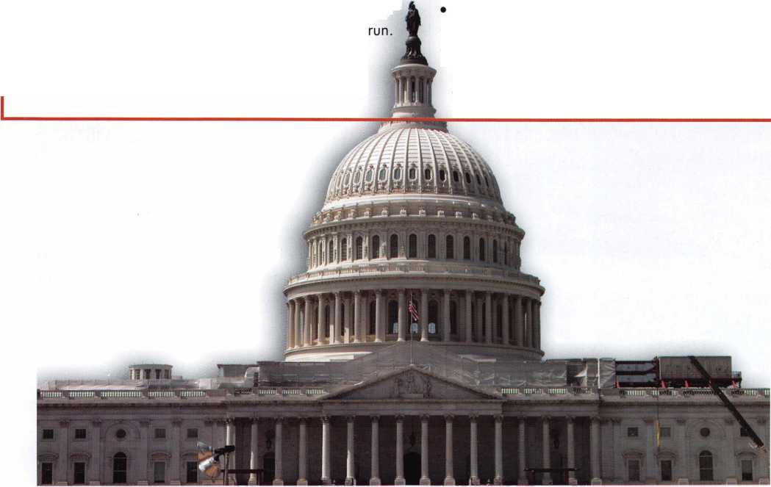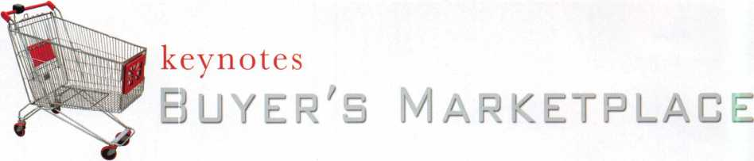

THREE SIZES OF HOPPERS FROM A & B SAFE CORP

Model #s

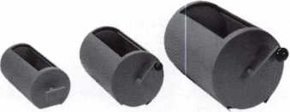

3 2 4

A & B SAFE CORPORATION

114 S. Delsea Drive, Suite 3  
Glassboro, NJ 08028-6237  
856-863-1186 Fax 856-863-1208

**NC Locksmith’s Association  
Regional Trade Show**

***DON’T MISS ITU***

* Show hours: Saturday, February 10th, 2007 8am -1 pm
* Free classes follow from 2pm - 4pm
* Renaissance Charlotte Suites Hotel, 2800 Coliseum Centre Drive, Charlotte NC 28217 1-800-HOTELS-1
* Admission $20 ($15 with proof of membership in any locksmith association)

•Thousands of dollars in door prizes will be given away!

* See the latest products and tools for safe techs, automotive and architectural locksmiths!!
* For additional information on NCLA, visit our website at [www.ncla.us](http://www.ncla.us)



Keynotes • December 2006

Facts on Sargent punches.

These new hand operated punches have a few unique features, plus specifications that are worthy enough to mention.

Two models are available, BP201-SGT-L and BP201- SGT-R.

Depending on milling (profile), the blanks are inserted one side or the other. Example; The L series is inserted from the left side and cuts bow to tip. The R series is inserted from the right side and cuts tip to bow, similar to IC products.

If your need is greater for R series, then the BP201- SGT-R will generate them from bow to tip, and the L series tip to bow. Models L or R, each does both.

The choice is yours.

SPACES:

.215'' to first cut center .156" between cut centers up to seven spaces. Factory space tolerance is ± .001".

DEPTHS:

Are in increments of .020", from .330" to .150" for a total of 10 depths 1 - 0 (10). Factory tol­erance is ± .002".

ANGLE:

Sharpest of most commercial specifications is 78 to 79 degrees. Tolerance if any is not specified by Sargent.

FLAT:

Small .051". No tolerance specified.

All of the above are incorporated in each hand punch by;

Locksmithing, Uni. LLC  
Phone: 302-575-0993  
E-mail: [ted@sargentpunch.com](mailto:ted@sargentpunch.com)



***ACCESS CONTROL***

***vmi^agiET***

BEKUUA1 **LOMBRHFT^**

^P ***DETERMINATOR***

*^cRutanMAJ°R HATA*

*^Crgzan*

***cR#t<***

STRATTEC

*Wed$ec&’»*

***PADLOCKS***

Master Lock

*Should you have questions about setting up  
an access control system including:  
wiring diagrams, switches, & installation  
information, give Bill or Paul a call @*

**800-231-4105**

**KUL (Mfe <§&>**

**Special Next Day Air Prices!**

*Place your order by 5 PM CST  
& get your order before noon the next day!*

*Sales Team with over  
65 Years Experience as Locksmiths!*

hlflake.cofn

Since 1912 800-231-4105

ecumv

**WEBER LOCK I**

KmogI

NORTO

*TOOLS* 1

» *OEM AND Ml*

**control + c onven»e n c e**

**LOCKCRAFT^j**

**BIANCHI**

**fLABl MAJOR**

**PRO-LOK**

*fpeuTson^L/tCL/1*

t *Locksmith fools EM* wSp*'*kmmmmmmm*

*HATAS*HOC A *i/cnSDD*

*mKsaBHtSKik*

*Wed$ec&m*

*Mill l./m*r ML

SCHLAGE

CAL-ROYAL

DOR-O-MATIC

**MONARCH**

1 |jQM

ComfX.

NATIONAL

VisalacK

*!R)JSZ»*

OLYMPUS^

Cbm$C^

**ASSA^cbm^C**

Si

1 MB BRIANE

**SARGENT**

DON-JO

**>RROW**

VON DUPRIN

[»f:^

I

A

*^SSrAm*

LIST $126

$ 82.50

CL210SS

LIST $519 LIST $522

$259.50 $261.00

MPC06 626 iQ!K/ME*F

LIST $655

DL2700*26D

Lifetime Warranty

SCHLAGE

LIST $499

200-26D1

LIST $380

$199.50

**1011 26D**

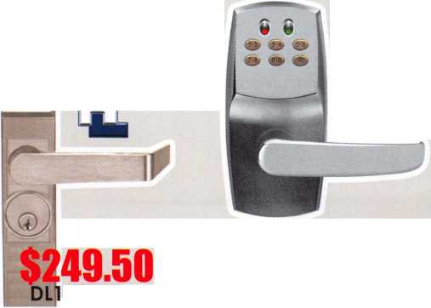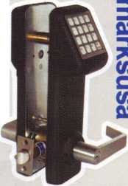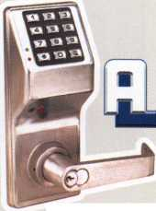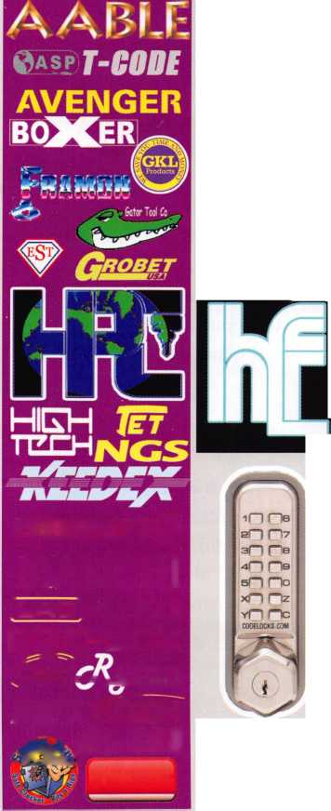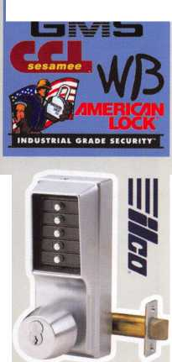

Why Membership?

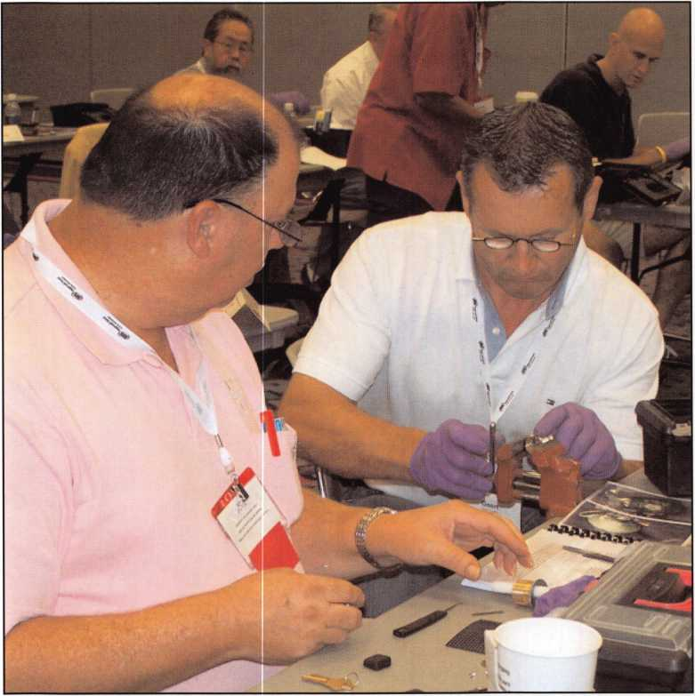

Physical security professionals help each other with education, networking and more.

ALOA members are tuned into this question and expect solid, tangible answers, as they should. Each member deter­mines what the value of joining means to them as individ­uals in relationship to their businesses. So, what do you get for writing that check to ALOA?

Are you familiar with the five ENDS of ALOA? These are the overarching strategies on which the membership and its leadership have chosen to focus its resources and energies.

The Membership  
Department of ALOA  
recently examined the  
member benefits and con-  
ducted an audit. This audit  
determined “Whats in it  
for the member?” Using  
the input of members, we

have established a stable of business solutions designed to:

1. Increase member profits;
2. Decrease member costs; and
3. Minimize risks to the member.

ALOA offers solutions for every aspect of your locksmith/access control business by working with what we call our external core partners. We are providing a conduit of access for our members to obtain the most favorable pricing for programs to aid them in making their business-

ALOA’s Ends are:

* Legislation E-l
* Communication E-2
* Education E-3
* Recognition E-4
* Professionalism E-5

ALOA has established busi-  
ness solutions that support  
those strategies and are in  
development to enhance  
and consistently update  
and improve those business  
solutions. This is all part of  
the future of ALOA, where  
we look at actionable,  
focused values that are true  
benefits of joining and  
belonging.



Keynotes • December 2006

**iVE ARE LISTENING TO YOUR NEEDS!**

CONTACT:

Associated Locksmiths of America 3500 Easy Street Dallas, TX 75247

Phone 800-532-2562 • Fax 214-819-9736 • [www.aloa.org](http://www.aloa.org)

**GET READY. CHANGE IS  
AROUND THE CORNER!**

Take a LOOK at some of the new things ALOA has planned for YOU in 2007.

ALOA is excited about the new changes in-store for everyone in 2007. For this membership cam­paign we have listened to the membership and are rapidly making changes to suit your needs.

\LOA offers you the strength of over 8,000 leading firms & individuals. ALOA is YOUR voice in the industry. ALOA represents the collective interests of the association to the press, government, and the public. ALOA is able to open many doors need­ed for your success in our ever-changing industry

• Don’t miss out as we roll out our new & improved Keynotes magazine introducing such interactive features as a Q&A section exclusively for members.

• More user-friendly ALOA website.

• More training & education opportunities.

• Better and broader network possibilities.

• ALOA store with more books & better merchandise; NEW products that help YOUR bottom line.

• RENEW TODAY to become eligible for great prizes including an exciting 7-day cruise!

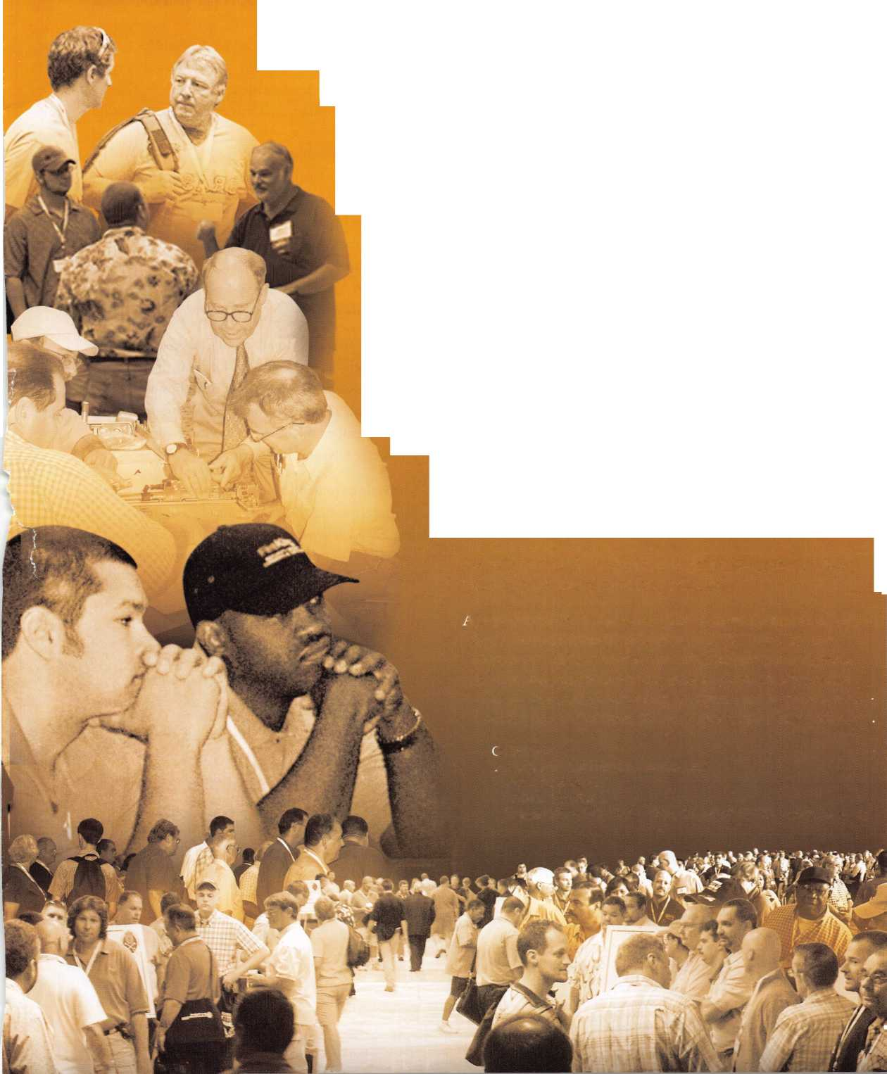

es more profitable and efficient. So let’s see whats available

through your membership in ALOA!

Professional Development

* ALOA education
* Industry certification
* **Keynotes —** helping you to stay on the cutting edge of technology
* Scholarship opportunities
* The ALOA store — providing money savings docu­ments on must have publications
* ALOA Volunteer Leadership - our leaders are key to the successful growth of our industry - BE PART of the FUTURE

Sales and Marketing

* The ALOA Convention and Security Expo - one of the best networking and education opportunities all under one roof
* Find A Locksmith — get the competitive edge with your online listing. Findalocksmith.com appears FIRST on a Google consumer search for “locksmith”
* On-staff graphic designers and advertising specialists who can help you create professional advertising with impact

Technology

* Industry validation with your ALOA membership.
* Legislative Alert - an online tool which allows you to play a proactive role on legislation that might impact you and other locksmiths/access control industry
* Online education opportunities
* ALOA website - provides a “members only” section — a great source of up-to-the-minute information on our industry

Business Management

* Free TECH Support - ALOA can be your connection to many or the industry experts.
* Legislative representation provided by ALOA’s Government Affairs Manager, who works both on the local and national level assisting locksmiths with leg­islative and licensing issues that effect the way you do business.
* Free industry bonding
* ALOA Business Partners offer member discounts on many of their services:

Allstate Insurance Avis Rent A Car Airborne Express MBNA Mastercard And others

This is a brief capsule summary of ALOA benefits but you can visit our website, [www.aloa.org](http://www.aloa.org) for more in-depth and contact information. We’ve designed these business solu­tions to help you answer the question, “What’s in it for me?” And remember, membership has its privileges—but only if you take advantage of them.

ALOA actively encourages member input, and participa­tion. Contact the ALOA Membership Development Manager, Ellen McEwen to discuss ideas or recommenda­tions so we can continue to build business solutions that:

* Increase your profits
* Decrease your costs
* Minimize your risks

**44**

Keynotes • December 2006

DOOr lamb Armor® Slop Giving Away Your Profits!

**O Hinge Shield**

Current security products only alert homeowners that they have already been violated.

The Hinge Shields fit around the existing door hinges end help prevent hinges from being kicked in

**A unique system that**

O flow Shield

The Door Shield reinforces the lock area of the door and helps prevent the door from splitting when kicked. Low profile model is available in colors to match your locks

Olamt Shield

The backbone of the system, the Jamb Shield is a 48" long sleeve that wraps around the lock side of the doorjamb, making it extremely difficult to kick in.

The Jamb Shield comes sizes to fit Standard [5.51 and Universal (5" to 121 lock spacing. Jamb and hinge shields secure to stud with 81/2" screws (included!

**reinforces the key strike  
points on entry doors  
and repairs damage  
from previous kick-ins**

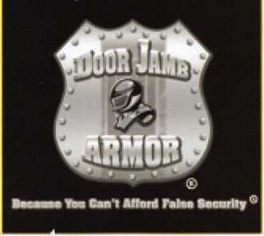

This product can repair existing

damage or prevent it from happening

in the first place.

Why You Should Sell floor lamb Armor

* This product will save you time and make you money
* Now, you don't need to call a carpenter to fix shattered jambs
* Multiple sales per customer and significant up-sell opportunities
* Do you work with any landlords?

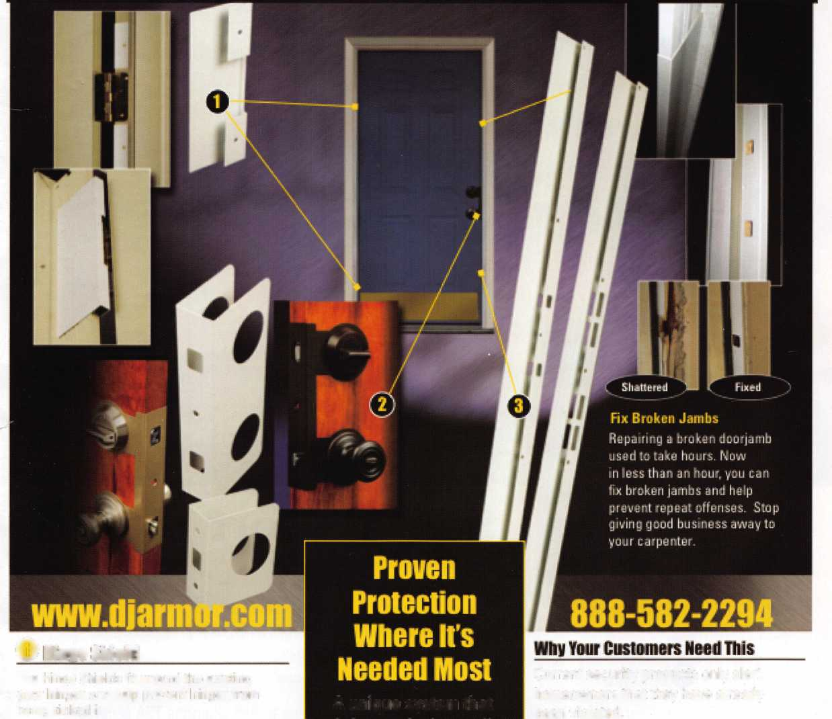

Security Window

**SearchAlert**

* Available in a variety of colors and styles
* Recognized & Accepted by the TSA
* Security Window cannot be altered with a paper clip
* Security Window can only be reset by a person knowing the combination
* Zinc Die Cast Body (Not Brittle Plastic)
* Steel Shackle is virtually unbreakable

The new SearchAlert Security window changes color from Green to Red when the TSA secured  
access device is used to open the lock, or when an unauthorized person has opened the lock  
using a counterfeit opening device. Travelers will now know when their SearchAlert Classic locks  
have been opened, and whether their bags have been searched by a TSA agent, or violated by an

unknown person. Protected by U.S. Patents 6,877,345 and 7,007,521. The Design of the Lock is a Registered Trademark® of The Eastern Company.

O

l **Red Window:**

Luggage has been searched.

**Green Window:**

Lock Not Opened.

The name you can trust for travel safety, security & accountability.



**Security Products** A Division of The Eastern Company **A Proud Union Company. (S.E.I.U.)**301 West Hintz Road | Wheeling, IL 60090 | Telephone: 800.733.8588 | Fax: 847.537.1881  
**[www.cclsecurity.com](http://www.cclsecurity.com)**



**TRAVEL SENTRY**

**APPROVED**

